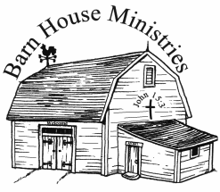**Scripture / #2 Bibliology –**

**The Wonders of The Bible**

Psalms 119

Psalms 138:2 I will worship toward thy holy temple, and praise thy name for thy lovingkindness and for thy truth: for thou hast magnified thy word above all thy name.

Psalms 119:129 Thy testimonies are wonderful: therefore doth my soul keep them.

Psalms 119:114 Thou art my hiding place and my shield: I hope in thy word.

Psalms 119:89 For ever, O LORD, thy word is settled in heaven.

Psalms 12:6-7 The words of the LORD are pure words: as silver tried in a furnace of earth, purified seven times. Thou shalt keep them, O LORD, thou shalt preserve them from this generation for ever.

Psalms 119:160 Thy word is true from the beginning: and every one of thy righteous judgments endureth for ever.

Matthew 24:35 Heaven and earth shall pass away, but my words shall not pass away.

Psalms 119:103 How sweet are thy words unto my taste! yea, sweeter than honey to my mouth!

1 Corinthians 14:19 Yet in the church I had rather speak five words with my understanding, that by my voice I might teach others also, than ten thousand words in an unknown tongue.

Revelation 1:1-3 The Revelation of Jesus Christ, which God gave unto him, to shew unto his servants things which must shortly come to pass; and he sent and signified it by his angel unto his servant John: Who bare record of the word of God, and of the testimony of Jesus Christ, and of all things that he saw. Blessed is he that readeth, and they that hear the words of this prophecy, and keep those things which are written therein: for the time is at hand.