A Doctrinal Sermon
on

GOD THE HOLY GHOST

Dr. Tom J Whitfield

Author's Request

Please read this booklet with your will surrendered to the Holy Ghost.
Purpose to read each scripture as it comes up in the text.
Do not bypass scripture to read what the author has written.
Thanks !!

A Doctrinal Sermon
on

GOD THE HOLY GHOST

Dr. Tom J Whitfield

2001

1

WHO IS THE HOLY GHOST?

He is JEHOVAH! GOD! LORD! He is Godhead!

"For there are three that bear record in heaven, the Father, the Word, and the Holy Ghost: and these three are one." First John 5:7

God the Holy Ghost is equal to God the Father, and God the Word in every way.

When referred to as third in the Trinity, it is only as reference, not power.
God the Holy Ghost is not a something or just a force, He is God !!!!!
God the Holy Ghost is a Spirit, same as the Father, same as the Word .

"God is a Spirit: and they that worship him must worship him in spirit and in truth." John 4:24

I would like to give seven offices of the Holy Ghost:
1.) He is the author of the word.
2.) He is our prayer partner.
3.) He is the teacher of the word.
4.) He is the executer of the word..
5.) He empowers the believer.
6.) He produces Godly fruit in our lives.
7.) He reproves and births the lost sinner.

I would like to give the First point and then the introduction to the message.

1.) God the Holy Ghost is the author of the word!
"All scripture is given by inspiration of God," II Timothy 3:16
"For the prophecy came not in old time by the will of man: but holy men of God spake as they were moved by the Holy Ghost." II Peter 1:21
"But those things, which God before had shewed by the mouth of all his prophets, that Christ should suffer, he hath so fulfilled." Acts 3:18

2

"Until the day in which he was taken up, after that he through the Holy Ghost had given commandments unto the apostles whom he had chosen." Acts 1:2

"Men and brethren, this scripture must needs have been fulfilled, which the Holy Ghost by the mouth of David spake before concerning Judas, which was guide to them that took Jesus.” Acts 1:16

Well spake the Holy Ghost by Esaias the prophet unto our fathers, Saying, Go unto this people, and say, Hearing ye shall hear, and shall not understand; .." Acts 28:25-26

"For David himself said by the Holy Ghost, The LORD said to my Lord, Sit thou on my right hand, till I make thine enemies thy footstool." Mark 12:36

“...Then Jeremiah called Baruch the son of Neriah: and Baruch wrote from the mouth of Jeremiah all the words of the LORD, which he had spoken unto him, upon a roll of a book...And Baruch the son of Neriah did according to all that Jeremiah the prophet commanded him, reading in the book the words of the LORD in the LORD'S house. ...Now it came to pass, when they had heard all the words, they were afraid both one and other.....And they asked Baruch, saying, Tell us now, How didst thou write all these words at his mouth? Then Baruch answered them, He pronounced all these words unto me with his mouth, and I wrote them with ink in the book.” Jeremiah 36:1-18

"Ye stiffnecked and uncircumcised in heart and ears, ye do always resist the Holy Ghost: as your fathers did, so do ye”. Acts 7:51

Many times the voice of the LORD, word from the LORD, spirit of the LORD, and word of the LORD in the Old Testament is God The Holy Ghost in mystery.

New Testament Confirms:
".. But Peter said, Ananias, why hath Satan filled thine heart to lie to the Holy Ghost, and to keep back part of the price of the land? ...Then Peter said unto her, How is it that ye have agreed together to tempt the Spirit of the Lord? Acts 5:3, 9

3

The intent or theme of the Bible was not given to men to write in their own words. The Holy Ghost gave the exact words he wanted spoken and written.

Now, I would like to give the introduction, this will make the remainder of the sermon more clear and meaningful.

I am glad we have God's written word! I also rejoice that it is written at sixth grade level. In Gail Riplinger's book, The Language of the K.J.V. Bible, A prisoner applied for G.E.D. tutoring and when tested was reading at 5th grade level and put on list for next year. The saved prisoner began devouring the K.J. Bible daily. The following year when re-examined for the G.E.D. program, he was reading at 17th grade - post graduate level. God has so structured his holy scripture. I highly recommend Mrs. Riplinger's book and the spending of many hours studying the content.

I am glad I live in the dispensation of today.
Def: dispensation: A system of principles and rules in operation during a specific time period.

JEHOVAH in scripture:

Old Testament Father, fire, hail, lighting, judgment, prophets, law, war, death, sacrifices.

Transition Word (Saviour/Son), love, mercy, compassion, fulfillment of the law, the ultimate sacrifice, the sin bearer, mediator.

New Testament Holy Ghost (kingdom of God) comforter, indweller, teacher, power of believer, security of believer.

JEHOVAH has always had a prescribed method of dealing with mankind.

Old Testament: God met with man in a building, in a city, Jerusalem !!

4

“And the LORD appeared to Solomon by night, and said unto him, I have heard thy prayer, and have chosen this place to myself for an house of sacrifice. If I shut up heaven that there be no rain, or if I command the locusts to devour the land, or if I send pestilence among my people; If my people, which are called by my name, shall humble themselves, and pray, and seek my face, and turn from their wicked ways; then will I hear from heaven, and will forgive their sin, and will heal their land. Now mine eyes shall be open, and mine ears attent unto the prayer that is made in this place. For now have I chosen and sanctified this house, that my name may be there for ever: and mine eyes and mine heart shall be there perpetually." II Chronicles 7: 12-16

The Mercy Seat and Ark dwelt in the temple:

“And the LORD said unto Moses, Speak unto Aaron thy brother, that he come not at all times into the holy place within the vail before the mercy seat, which is upon the ark; that he die not: for I will appear in the cloud upon the mercy seat. Thus shall Aaron come into the holy place: with a young bullock for a sin offering, and a ram for a burnt offering. For the life of the flesh is in the blood: and I have given it to you upon the altar to make an atonement for your souls: for it is the blood that maketh an atonement for the soul."
Leviticus 16:2-3, 17;11

“Now when Daniel knew that the writing was signed, he went into his house; and his windows being open in his chamber toward Jerusalem, he kneeled upon his knees three times a day, and prayed, and gave thanks before his God, as he did aforetime.”
Daniel 6:10

Temple Worship:

Worship: to prostrate oneself in homage, to adore, to be in awe, on the face Reverence: To fear, be afraid, to dread, to be submissive
(Blood sacrifices, blowing of trumpets, stonings, banishments, gold covered temple, Mercy Seat, Ark, priest, fire, etc.)

Jesus kept the law, he worshipped in temple in Jerusalem, read scripture in temple. "And he went into the temple, and began to cast out them that sold therein, and them that bought; Saying unto them, It is written, My house is the house of prayer: but ye have made it a den of thieves. And he taught daily in the temple. And in the daytime he was teaching in the temple; and

5

at night he went out, and abode in the mount..And all the people came early in the morning to him in the temple, for to hear him. Luke 19:45-47, 21:37

Jesus Instructed the leper to show himself to the priest as to being healed of leprosy. “And he put forth his hand, and touched him, saying, I will: be thou clean. And immediately the leprosy departed from him. And he charged him to tell no man: but go, and shew thyself to the priest, and offer for thy cleansing, according as Moses commanded, for a testimony unto them. Luke 5:13

However, things changed! When Jesus on the cross cried, “It is finished”...And the veil of the temple was rent in twain from the top to the bottom." and He arose from the grave and presented his blood on the mercy seat in the third heaven: "The Holy Ghost this signifying, that the way into the holiest of all was not yet made manifest, while as the first tabernacle was yet standing: It was therefore necessary that the patterns of things in the heavens should be purified with these; but the heavenly things themselves with better sacrifices than these. For Christ is not entered into the holy places made with hands, which are the figures of the true; but into heaven itself, now to appear in the presence of God for us:" John 19:30, Mark 15:38, Hebrews 9, earthly temple worship at Jerusalem was abolished.

Things changed as to worship and service!
God's dealings with mankind changed, not the same as in the Old Testament!

1.) Promises Given:
"He that believeth on me, as the scripture hath said, out of his belly shall flow rivers of living water. (But this spake he of the Spirit, which they that believe on him should receive: for the Holy Ghost was not yet given; because that Jesus was not yet glorified.) But the Comforter, which is the Holy Ghost, whom the Father will send in my name, he shall teach you all things, and bring all things to your remembrance, Nevertheless I tell you the truth; It is expedient for you that I go away: for if I go not away, the Comforter will not come unto you; but if I depart, I will send him unto you. John 7:38-39, 14:26, 16:7

6

2.) Promises Fulfilled:
"What? know ye not that your body is the temple of the Holy Ghost which is in you, which ye have of God, and ye are not your own? For ye are bought with a price: therefore glorify God in your body, and in your spirit, which are God's."
I Corinthians 6:19, 20

A New Covenant! ---- God in us!
Mankind entered into the dispensation of God the Holy Ghost!
God the Holy Ghost is no longer in mystery form.

New Testament ---- New Covenant!
The exact moment we repented of our sins and trusted Jesus Christ as our Saviour....something else happened simultaneously!

God the Holy Ghost moved into our spirit and regenerated it! He dwells there permanently on his throne (kingdom of God).

"For the kingdom of God is not meat and drink; but righteousness, and peace, and joy in the Holy Ghost.' "The kingdom of God cometh not with observation: Neither shall they say, Lo here! Or, lo there! for, behold, the kingdom of God is within you.”
Romans 14:17, Luke 17:20-21

We as believers do not go to church to worship God!

We as believers do not assemble to meet God in his holy temple!

We meet to get fed from his word and encourage each other as believers!

I would like to give you some things you will hear in the average Church as to ignorance of God's word.

Recently on a business trip to Orlando, Florida my wife and I went to a good fundamental Baptist church on Wednesday night. The regular Pastor

7

was on a mission trip. A man previously saved in their church while in the Navy and visiting while on vacation spoke.

First, he displayed his W.W.J.D. bracelet and gave a ten minute discourse on "What would Jesus do?"

Truth: We do not need to concern ourselves as to "what would Jesus do?” We need to obey what God the Holy Ghost who dwells inside is telling us to do or not to do! There is a lot of difference!

Second, he gave a discourse on the poem/song "What if Jesus came to your house today?" Would you have to get the television guide off the Bible and dust it? Would you have to hurriedly get the beer out of frig? Would you have hide the playboy book? Would you have to change television and radio channel?

TRUTH: Good news, Jesus is not coming to your house!

Want a Shocker? God the Holy Ghost is there all the time 24/7.

Copious space has been allotted throughout booklet for notes:

8
Average Sermons:
When God looks down from heaven he wants to see four things in your Life. He wants to see you: Smiling, Sincere, Serving, Soul winning.

Truth. He is not looking down from heaven checking on us. He is on earth, inside the believer.

Four ways how to get more of Jesus.
By seeking, by separation, by service, by speaking.

Truth. We do not get more of Jesus, but rather we grow and become more spiritual as we yield more of ourselves to God the Holy Ghost.

Song:
Brethren we have met to worship the Lord our God – All is vain unless the Spirit of the Holy One comes down.

Truth. He, the Holy Ghost has been down ever since Jesus went up 2000 years ago.

Scripture:
Let's pray and ask Jesus to meet with us as he said in Matthew 18:20.

Truth. Jesus is seated on the right hand of God. He is not meeting with us What about verse nine of same chapter?
Or
I baptize you in the name of Father, Son, and Holy Spirit.

Truth. The command is: “..baptizing them in the name of the Father, and of the Son, and of the Holy Ghost". Matthew 28:19.

(Brother Al Lacy said he asked a lot of preachers why they used Holy
Spirit instead of Holy Ghost when baptizing. Most thought that is what the Bible said and started using the correct scripture when baptizing.)

Camp meeting:
Let's ask God to show up and show out!

Truth; He is already here!

9

Temple Violation:
Don't bring that beer in the church and violate the Temple of God!

Truth: You violate the temple of God when you pour it down your throat, Not when you bring it into a church building..
What? know ye not that your body is the temple of the Holy Ghost which is in you?
First Corinthians 6:19, 20

What a sobering thought! God the Holy Ghost dwells in us!

I would like to reiterate that we are living in the dispensation of God the Holy Ghost!
A very important New Testament Doctrine! The New Testament Temple of God is the individual human believer.

This brings us to the question :
Why do K.J.V. people use the term Holy Spirit instead of Holy Ghost ?????????????????????????????????????????????????
WHY? WHY? WHY?

Common prayer in most churches;
Dear Holy Spirit of God work in the service today!
Or
Dear Father, we ask you send your Holy Spirit to work in us today!

Common scripture reading and the following dialogue in most churches.

"Not by works of righteousness which we have done, but according to his mercy he saved us, by the washing of regeneration, and renewing of the Holy Ghost.” Titus 3:5

10

Now we see in this passage that the Holy Spirit regenerates us and we are saved. After we are saved we need to confess our sins and read the word and the Holy Spirit will renew our minds.

"For the prophecy came not in old times by the will of man: but holy men of God spake as they were moved by the Holy Ghost.” II Peter 1:21

Now we see in this passage that our bible was not written by the will and intellect of men. The Holy Spirit of God instructed them what to write.

Bible word inventory

Holy Ghost----------vs.----------Holy Spirit
90---------------------------------- 1

Holy Ghost----------vs.----------holy Spirit
90 ----------------------------------6

New Testament setting;
Holy Ghost----------vs.----------Holy Spirit
66 ----------------------------------0

Holy Ghost----------vs.----------holy Spirit
66-----------------------------------3

When holy is capitalized (Holy) it always refers to JEHOVAH (Godhead).

11

Holy Spirit is never used in New Testament setting!

However, holy Spirit is used three times, holy always being an adjective.

Also: (holy apostles, holy prophets, holy temple, holy word, holy scripture, holy child Jesus, holy thing, holy hands, holy men of God, holy angels, holy Jerusalem, holy covenant, holy ground, holy temple of God, holy brethren, holy city, holy place, holy women) with holy always being an adjective.

Names referencing the Holy Ghost in New Testament:
Comforter, Spirit of truth, Spirit of God, Spirit of the Lord, Spirit of adoption, Spirit of life, the Spirit, Spirit of Jesus Christ, Spirit of promise, Spirit of Christ, Spirit of his Son, eternal Spirit.

I have observed churches and studied Christians, Pastors, and Evangelists for five years and spent many hours preparation on this sermon;

I would like to give you three reasons K.J.V. believers use Holy Spirit instead of Holy Ghost!

1.) The Fear of being associated with a denomination or cult that abuses the name of God the Holy Ghost !! (Jim Jones to Clownsville Community Church).

2.) The influence of perverted text that believers read, listen to, watch on television, or pull from computer soft ware (n.i.v.- r.s.v.- r.v.- t.e.b.)
For instance, Charles Stanley; I was in the car a couple weeks ago and scanning for good music when I came across his broadcast. He was speaking on the three Hebrew children being in the furnace. He did a good job of laying out the message with scriptural principles, etc.. Then he read the scripture, Daniel 3:25 and gave the n.i.v. reading: "that the fourth is like a son of the gods." The A.V. reads, “the fourth is like the Son of Go.”

12

If believers listen to these perverted sources day after day, then they will not even know the correct reading of God's word.

3.) The programming and brain washing of so called great men of the past, such as Charles Spurgeon, John R. Rice, R.A. Torrey, Vernon McGee, Bob Jones Sr., Lee Robertson, Jack Hyles, Jerry Falwell and others (some even wrote books on Holy Spirit). The person who most influenced these people was C.I. Scofield. He was an intellectual lawyer who associated with liberal Bible scholars of that day.

(The Scofield Reference Bible, Introduction, page iv January 1,1909) The Revised Version, which has now been before the public for twenty- seven years, gives no indication of becoming in any general sense the people's Bible of the English-speaking world. The discovery of the Sinaitic Ms. and the labors in the field of textual criticism of such scholars as Griesbach, Lachmann, Tischendorf, Tregelles, Winer, Alford, and Westcott and Hort, have cleared the Textus Receptus of minor inaccuracies, while confirming in a remarkable degree the general accuracy of the Authorized Version of that text. Such emendations of the text as scholarship demands have been placed in the margins of this edition, which therefore combines the dignity, the high religious value, the tender association of the past, the literary beauty and remarkable general accuracy of the Authorized Version, with the results of the best textual scholarship. C.I. Scofield

Emendations: correction of a text fault by qualified scholars????

In many churches the Old Scofield Bible is recommended to new converts as the best study bible available.

Hey, I am talking to people that say they believe the English K.J.V. is God's preserved word, without error!!

Brother Tom, The word for "ghost" in the original manuscripts is translated as "Pneuma" which mean wind or spirit.

Wait! Wait!! There are no original manuscripts, remember!!!!!!

13

Plus we state we believe the English K.J.V. is superior to any Greek/Hebrew Manuscripts, Right!!!!!

Let's keep the battle ground level! Let's be Honest! THINK!!!

Did you know the N.I.V. never uses the word Holy Ghost? It always follows the R.V. (Westcott/Hort) perverted text and uses Holy Spirit. Why? because the word international means it can be used for any religion. To other religions their god is a Holy Spirit. However, no other religion uses the name Holy Ghost because God the Holy Ghost is JEHOVAH. He is our God, but not theirs.

Guess What? The dear Old Scofield Bible changes Holy Ghost to Holy Spirit every time in the notes or margin. Now, ain't that something?

What you getting upset about, Calm down!

You say, my Scofield is K.J.V. text and I do not use the notes or margin references.
Well then, why are you using:

Holy Spirit instead of Holy Ghost
love instead of charity
demons instead of devils
creation instead of creature
hades instead of hell
authority instead of power
age instead of world

If my Bible never uses the name Holy Spirit in a New testament setting, why would I change Holy Ghost to Holy Spirit? Can you answer that?

The Tyndale Bible of 1525 did not change to Holy Spirit!
The Great Bible of 1539 did not change to Holy Spirit!
The Geneva Bible of 1562 did not change to Holy Spirit!
The Bishop's Bible of 1602 did not change to Holy Spirit!
The K.J.V. Bible of 1611 did not change to Holy Spirit!

14

If I use Holy Spirit when the A.V. uses Holy Ghost, then I have become a Bible perverter.

We all have been influenced by the perverted text. We all have unknowingly used it in ignorance. I have been working daily for over five years correcting my usage. I personally do not want to stand before the Judgment Seat of Christ and be charged with changing the word. I want to be correct in the use of God's word.

We need to use the proper name given in the scripture.
Holy Ghost of God is not correct. He is not of God, he is God the Holy Ghost!

Hold it! Hold it!! Let me sidetrack a lie from the devil.

I am not revealing anything new! I am just clearing up something from God's word that has been trampled on for 120 years.

Wait! This correction does not change anything as to our operation as a believer.

Example: The Bible tells me to witness to the lost. I tell the lost person about Jesus Christ the Saviour, not the Holy Ghost. However, God the Holy Ghost, empowers me, he gives me boldness, clarity of mind, calms my nerves, executes the written word that I present to them, reproves the sinner, and births the sinner into the family of God.

Is it proper to pray to God the Holy Ghost? Yes!

After coming to the Throne of Grace and thanking God the Father for his goodness, mercy, longsuffering, blessing, and asking for forgiveness of sins, through the shed blood of the Lord Jesus Christ....It is proper to pray; Dear Holy Ghost I ask that you empower me to stand for you today. I ask for power and boldness to witness and give out tracts. Please empower me to

15

fear you and obey the word. Please work in me today to both will and do your good pleasure. My desire is to please you in everything I do, say, and think. I ask that you produce your fruit in my life today. I ask for your protection and guidance today. In Jesus Name I pray, Amen.

Relax! Relax! I am speaking to the Cream of the Crop! I'm speaking to men, women, boys, and girls who are dedicated to God, faithful to church, and believe the English King James Bible to be God's word without error. Let us not be guilty of changing God's word. Let us not condemn/criticize others that change God's word and be guilty of the same sin.

Let us not become the chief of hypocrites

Now, back to sermon: Who is God the Holy Ghost?

2.) God the Holy Ghost is our prayer partner !

"But ye, beloved, building up yourselves on your most holy faith, praying in the Holy Ghost, ...Likewise the Spirit also helpeth our infirmities: for we know not what we should pray for as we ought: but the Spirit itself maketh intercessions for us with groanings which cannot be uttered. And he that searcheth the hearts knoweth what is the mind of the Spirit, because he maketh intercessions for the saints according to the will of God....For through him we both have access by one Spirit unto the Father."
Jude 20 - Romans 8:26-27 - Ephesians 2:18

The Holy Ghost presents a sorted prayer (in the will of God) to the throne!

3.) God the Holy Ghost is the teacher of the word!

“Howbeit when he, the Spirit of truth, is come, he will guide you into all truth...But as it is written, Eye hath not seen, nor ear heard, neither have entered into the heart of man, the things which God hath prepared for them that love him. But God hath revealed them to us by his Spirit: for the Spirit searcheth all things, yea, the deep things of God. Which things also we speak, not in the words which man's wisdom teacheth, but which the Holy Ghost teacheth: comparing spiritual things with spiritual...but the anointing

16

which ye have received of him abideth in you, and ye need not that any man teach you: but as the same anointing teacheth you of all things, and is truth, and is no lie, and even as it taught you, ye shall abide in him.” John 16:13 - I Corinthians 2;9-13 - I John 2:27

Only God the Holy Ghost can teach us spiritual truths. Man can only present it as a sermon or study material.

The Holy Ghost teaches us in four ways:

Recall of scriptures: He brings to mind scripture that we have read, heard in a sermon, or memorized to help our understanding and develop our spiritual growth.

Implantation of thoughts: He gives us thoughts as simple as, "I wonder why ?" To cause us to dig in the word and seek him in prayer for understanding and guidance.

Direction; He guides us as we read, meditate, and study doctrine. He knows what we need and when we need it. He will always point out error if we are sensitive to his voice.

Illumination of the scripture. He will cause a portion of scripture to nearly jump off the page. It will be scripture we have read dozens of times. However, the time was not right for it to be revealed to us until now. In the U.S.M.C. they would say, "He dropped a Luminous grenade over it.”

You reckon it would be wise to ask the One who wrote the scripture, to teach us? We need to ask the Holy Ghost for wisdom and understanding as how to obey and apply the scripture in our everyday life.

4.) God the Holy Ghost is the executer of the word!

"For the word of God is quick, and powerful, and sharper than any twoedged sword, piercing even to the dividing asunder of soul and spirit, and of the joints and marrow, and is a discerner of the thoughts and intents of the heart.....and the sword of the Spirit, which is the word of God:.. Hebrews 4:12 - Ephesians 6:17

He uses the word of God to show us adjustments we need to make in our daily walk each day. He shows us what is right or wrong in our lives. He reveals wickedness deep in our hearts. Godly sorrow is a work of God the

17

Holy Ghost. When he reproves us of a sin, we need to confess that sin and be restored to fellowship immediately!!!! "If we say that we have no sin, we deceive ourselves, and the truth is not in us. If we confess our sins, he is faithful and just to forgive our sins, and to cleanse us from all unrighteousness. If we say that we have not sinned, we make him a liar, and his word is not in us. But if we walk in the light, as he is in the light, we have fellowship on with another, and the blood of Jesus Christ his Son cleanseth us from all sin. First John 1:7-10

Confess: to acknowledge something as true: to admit as true.
To confess something as sin, is to see it as God says it is, wicked! If we as believers see sin as exceedingly wicked, then we should immediately repent and confess and be restored.

Evangelist T.V. Compton says, "To confess a sin is to take God's side against your own self. God you are completely right and Compton is completely wrong." Amen!

Through the reproof of the Holy Ghost and promise of the scripture, we can walk in fellowship and live the abundant life. "If we live in the Spirit, let us also walk in the Spirit"... Walk in the Spirit and ye shall not fulfill the lust of the flesh."
Galatians 5:16, 25

5.) God the Holy Ghost empowers us to serve him.

“For it is God which worketh in you both to will and do of his good pleasure...What? know ye not your body is the temple of the Holy Ghost which is in you, which ye have of God, and ye are not your own. For ye are bought with a price: therefore glorify God in your body, and in your spirit, which are God's." Philippians 2:13 - I Corinthians 6:19

6.) God the Holy Ghost produces Godly fruit in our lives
"But the fruit of the Spirit is love, joy, peace, longsuffering, gentleness, goodness, faith, meekness, temperance: against such there is no law." Galatians 5:22-23

18

We cannot produce this fruit on our own, we are a proven failure. We produce exactly the opposite on our own. Only the Holy Ghost can produce this divine fruit in our life.

7.) God the Holy Ghost reproves and births the lost sinner.

“And when he is come, he will reprove the world of sin, and of righteousness and of judgment....Except a man be born of water and of the Spirit, he cannot enter into the kingdom of God. That which is born of the flesh is flesh; and that which is born of the Spirit is spirit....Being born again, not of corruptible seed, but of incorruptible, by the word of God, which liveth and abideth forever....of his own will beget he us with the word of truth." John 16:18, 3:5-6 - First Peter 1:23 - James 1:18

The Holy Ghost using the written word of God reproves a person of their sin and then reveals to them their lost condition. He then magnifies the Saviour. If the sinner responds positive, the Holy Ghost takes the written word of God and births them into the kingdom of God.

Conclusion: When we stand before the Judgment Seat of Christ, we will be without excuse! "Now unto him that is able to do exceeding abundantly above all that we ask or think, according to the power that worketh in us. Ephesians 3:20

Please study the presented material and seek to please and honor God in every endeavor.

“If the scripture leads us into a head on collision with the most Godly, Pious, Dedicated, Intellectual, Scholarly Christians of the last seventeen centuries, let us follow the
scriptures." ~PSR~

19

The following scripture comparisons are identical from the R.V. (Westcott/Hort), Scofield Study Bible notes/margins, and the N.I.V.

These 337 comparisons represent approximately 16% of changes from the Received Text. You can more fully see the subtilty of the devil by installing the R.V. (Westcott/Hort) perversion as margin/foot notes in the Scofield Study Bible with the King James Version being the main text.

For over 100 years the enemy has used this covert weapon to spearhead the apostasy movement that is so evident in today's fundamental circles.

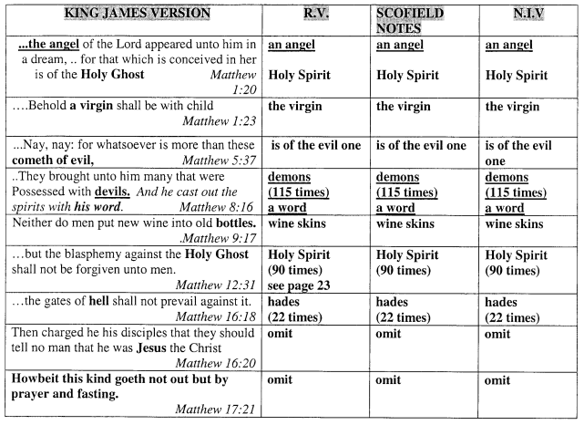

20

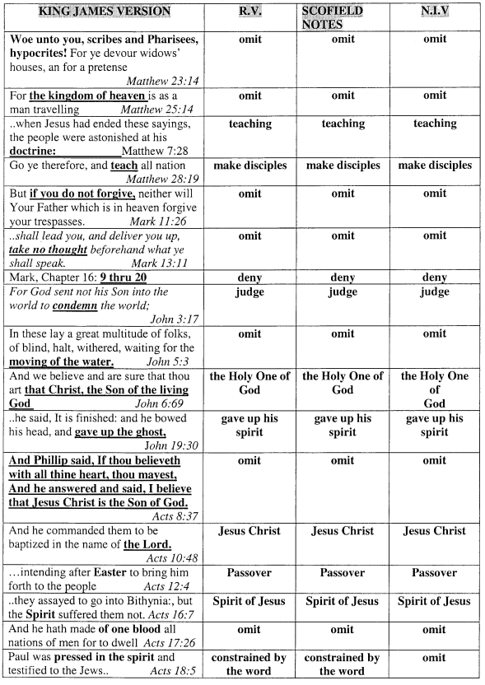

21

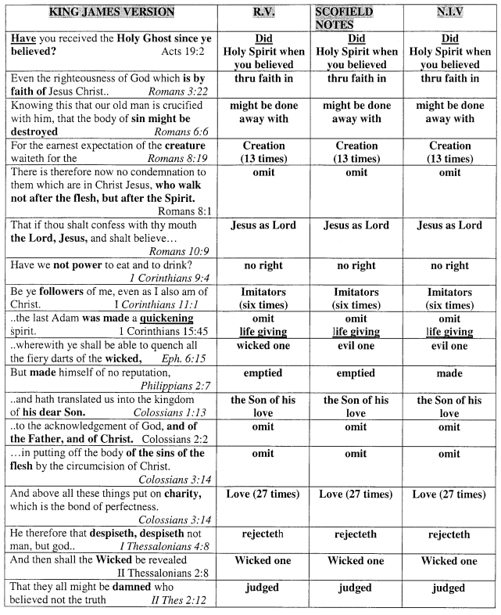

22

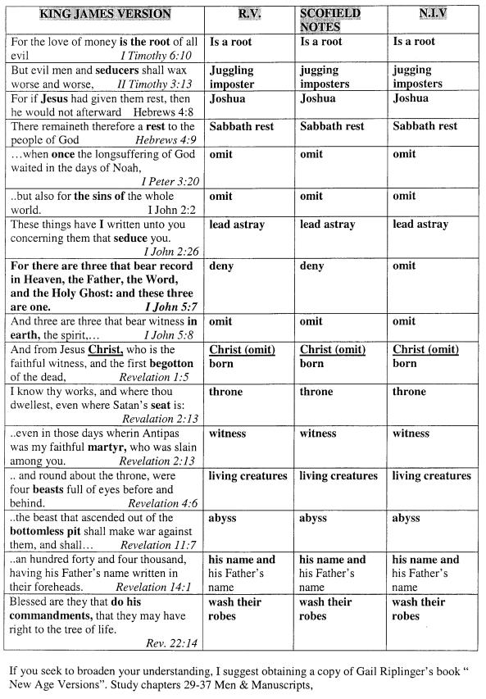

23
HOLY GHOST - VS - HOLY SPIRIT

The rejection of the Trinity (Word & Holy Ghost) by seducing spirits using men and manuscripts is revealed in the following footnotes and alteration of scripture.

Scofield notes:*
I John 5:7 “For there are three that bear record in heaven, the Father, the Word, and the Holy Ghost: and these three are one.”
* (It is generally agreed that verse seven has no authority, and has been inserted.)
Matthew 28:19 “Go ye therefore, and teach all nations, baptizing them in the name* of the Father, and of the Son, and of the Holy Ghost:
* (name: The word is in the singular, the “name”, not names. Father, Son, and Holy Spirit is the final name of the one true God.
It affirms: 1.) That God is one. 2.) That he subsists in a personality which is threefold, indicated by relationship as Father and Son; by a mode as being Spirit;

TEXT CHANGE made 90 times from Holy Ghost in K.J.V.- to- Holy Spirit in the R.V. (Westcott/Hort), Scofield Study Bible, and N.I.V.)
Matthew 1:18 ... When as his mother Mary was espoused to Joseph, before they came together, she was found with child of the Holy Ghost.
Matthew 1:20... The angel of the Lord appeared unto him in a dream, saying, Joseph, thou son of David, fear not to take unto thee Mary thy wife: for that which is conceived in her is of the Holy Ghost.
Matthew 3:11... He shall baptize you with the Holy Ghost, and with fire.
Matthew 12:31… All manner of sin and blasphemy shall be forgiven unto men: but the blasphemy against the Holy Ghost shall not be forgiven unto men.
Matthew 12:32 ... But whosoever speaketh against the Holy Ghost, it shall not be forgiven him, neither in this world, neither in the world to come.

24
Matthew 28:19... Go ye therefore, and teach all nations, baptizing them in the
name of the Father, and of the Son, and of the Holy Ghost.
Mark 1:8... I indeed have baptized with water: but he shall baptize you with the Holy Ghost.
Mark 3:29... But he that shall blaspheme against the Holy Ghost hath never forgiveness, but is in danger of eternal damnation.
Mark 12:36... For David himself said by the Holy Ghost, The Lord said to my Lord, Sit thou on my right hand, till I make thine enemies thy footstool.
Mark 13:11... but whatsoever shall be given you in that hour, that speak ye: for it is not ye that speak, but the Holy Ghost.
Luke 1:15... and he shall be filled with the Holy Ghost, even from his mother's womb.
Luke 1:35… And the angel answered and said unto her, The Holy Ghost shall come upon thee.
Luke 1:41... when Elisabeth heard the salutation of Mary, the babe leaped in her womb; and Elisabeth was filled with the Holy Ghost.
Luke 1:67... And his father Zacharias was filled with the Holy Ghost, and prophesied saying,
Luke 2:25-26... whose name was Simeon; and the same man was just and devout, waiting for the consolation of Israel: and the Holy Ghost was upon him. And it was revealed unto him by the Holy Ghost, that he should not see death, before he had seen the Lord's Christ
Luke 3:16... The latchet of whose shoes I am not worthy to unloose: he shall baptize you with the Holy Ghost and with fire.
Luke 3:22... and the Holy Ghost descended in a bodily shape like a dove upon him, and a voice came from heaven, which said, Thou art my beloved Son; in thee I am well pleased.
Luke 4:1… And Jesus being full of the Holy Ghost returned from Jordan, and was led by the Spirit into the wilderness

25
Luke 12:10… And whosoever shall speak a word against the Son of man, it shall be forgiven him: but unto him that blasphemeth against the Holy Ghost it shall not be forgiven.
Luke 12:12… For the Holy Ghost shall teach you in the same hour what ye ought to say.
John 1:33... Upon whom thou shalt see the Spirit descending, and remaining on him, the same is he which baptizeth with the Holy Ghost.
John 7:39… (But this spake he of the Spirit, which they that believe on him should receive: for the Holy Ghost was not yet given; because that Jesus was not yet glorified).
John 14:26… But the Comforter, which is the Holy Ghost, whom the Father will send in my name, he shall teach you all things, and bring all things to your remembrance, whatsoever I have said unto you.
John 20:22… And when he had said this, he breathed on them, and saith unto them, Receive ye the Holy Ghost.
Acts 1:2… Until the day in which he was taken up, after that he through the Holy Ghost had given commandments unto the apostles whom he had chosen.
Acts 1:5... For John truly baptized with water; but ye shall be baptized with the Holy Ghost not many days hence.
Acts 1:8… But ye shall receive power, after that the Holy Ghost is come upon you:
Acts 1:16... Men and brethren, this scripture must needs have been fulfilled, which the Holy Ghost by the mouth of David spake before concerning Judas,...
Acts 2:4… And they were all filled with the Holy Ghost, and began to speak with other tongues as the Spirit gave them utterance.
Acts 2:33... Therefore being by the right hand of God exalted, and having received of the Father the promise of the Holy Ghost, ..
Acts 2:38... Repent and be baptized every one of you in the name of Jesus Christ for the remission of sins, and ye shall receive the gift of the Holy Ghost.
Acts 4:8… Then Peter, filled with the Holy Ghost, said unto them, Ye rulers of the people, and elders of Israel.

26
Acts 5:3... But Peter said, Ananias, why hath Satan filled thine heart to lie to the
Holy Ghost, and to keep back part of the price of the land?
Acts 5:32... And we are his witnesses of these things; and so is also the Holy Ghost, whom God hath given to them that obey him.
Acts 6:3… Wherefore, brethren, look ye out among you seven men of honest report, full of the Holy Ghost and wisdom, whom we may appoint over this business.
Acts 6:5… And the saying pleased the whole multitude: and they chose Stephen, a man full of faith and of the Holy Ghost
Acts 7:51... Ye stiffnecked and uncircumcised in heart and ears, ye do always resist the Holy Ghost: as your fathers did, so do ye.
Acts 7:55... But he being full of the Holy Ghost, looked up steadfastly into heaven, and saw the glory of God, and Jesus standing on the right hand of God.
Acts 8:15, 17, 18, 19... Who, when they were come down,.... received the Holy Ghost. Then laid they their hands on them, and they received the Holy Ghost. And when Simon saw that through laying on of the apostles' hands the Holy Ghost was given, he offered them money, Saying, give me also this power, that on whosoever I lay hands, he may receive the Holy ghost.
Acts 9:17... Brother Saul, the Lord, even Jesus, that appeared unto thee in the way as thou camest, hath sent me, that thou mightest receive thy sight, and be filled with the Holy Ghost.
Acts 9:31... Then had the churches rest throughout all Judea...and were edified; and walking in the fear of the Lord, and in the comfort of the Holy Ghost were multiplied.
Acts 10:38... How God anointed Jesus of Nazareth with the Holy Ghost and with power: who went about doing good, and healing all that were oppressed of the devil ........
Acts 10:44-45… While Peter yet spake these words, the Holy Ghost fell on all them which heard the word. ...because that on the Gentiles also was poured out the gift
10:47... Can any man forbid water, that these should not be baptized, which have received the Holy Ghost as well as we ?
Acts 11:15... And as I began to speak, The Holy Ghost fell on them, as on us at the beginning.

27
Acts 11:16... John indeed baptized with water; but ye shall be baptized with the Holy Ghost.
Acts 11:24... For he was a good man, and full of the Holy Ghost and of faith,
Acts 13:2,.4... As they ministered to the Lord, and fasted, the Holy Ghost said, Separate me Barnabas and Saul for the work whereunto I have called them. So they, being sent forth by the Holy Ghost
Acts 13:9… Then Saul, (who is also called Paul,) filled with the Holy Ghost, set his eyes on him.
Acts 13:52... And the disciples were filled with joy, and with the Holy Ghost.
Acts 15:8… And God, which knoweth the hearts, bare them witness, giving them the Holy ghost ....
Acts 15:28... For it seemed good to the Holy Ghost, and to us, to lay upon you no greater burden.
Acts 16:6... Now when they had gone throughout Phrygia and the region of Galatia and were forbidden of the Holy Ghost to preach the word in Asia,
Acts 19:2… He said unto them, Have you received the Holy Ghost since ye believed? And they said unto him, We have not so much as heard whether there be an Holy Ghost.
Acts 19:6… And when Paul had laid his hands upon them, the Holy Ghost came on them;
Acts 20:23... Save that the Holy Ghost witnesseth in every city, saying that bonds and afflictions...
Acts 20:28... Take heed therefore unto yourselves, and to all the flock, over the which the Holy Ghost hath made you overseers, to feed the church of God which he hath purchased with his own blood
Acts 21:11... he took Paul's girdle, and bound his own hands and feet, and said, Thus saith the Holy Ghost, So shall the Jews at Jerusalem bind the man that owneth this girdle...

28
Acts 28:25-26... Well spake the Holy Ghost by Esaias the prophet unto our fathers, saying, go unto this people, and say, Hearing ye shall hear, and shall not understand; and seeing ye shall see,
Romans 5:5… And hope maketh not ashamed, because the love of God is shed abroad in our hearts by the Holy Ghost which is given unto us.
Romans 9:1… I say the truth in Christ, I lie not, my conscience also bearing me witness in the Holy Ghost, That I have great heaviness and continual sorrow in my heart.
Romans 14:17... For the kingdom of God is not meat and drink; but righteousness, and
peace, and joy in the Holy Ghost.
Romans 15:13… Now the God of hope fill you with all joy and peace in believing, that ye may abound in hope, through the power of the Holy Ghost.
Romans 15:16... That I should be the minister of Jesus Christ to the Gentiles, ministering the gospel of God, that the offering up of the Gentiles might be acceptable, being sanctified by the Holy Ghost.
I Corinthians 2:13…Which things also we speak, not in the words which man's wisdom teacheth, but which the Holy Ghost teacheth; comparing spiritual things with spiritual.
I Corinthians 6:19… What? know ye not that your body is the temple of the Holy Ghost which is in you, which ye have of God, and ye are not your own?
I Corinthians 12:3… Wherefore I give you to understand, that no man speaking by the Spirit of God calleth Jesus accursed: and that no man can say that Jesus is the Lord, but by the Holy Ghost.
II Corinthians 6:6... By pureness, by knowledge, by longsuffering, by kindness, by the Holy Ghost, ..
II Corinthians 13:14... The grace of the Lord Jesus Christ, and the love of God, and the communion of the Holy Ghost, be with you all. Amen.
I Thessalonians 1:5... For our gospel came not unto you in word only, but also in power, and in the Holy Ghost, and in much assurance; as ye know what manner of men we were among you.....

29
I Thessalonians 1:6... And ye became followers of us, and of the Lord, having received the word in much affliction, with joy of the Holy Ghost:
II Timothy 1:14... That good thing which was committed unto thee keep by the Holy Ghost which dwelleth in us.
Titus 3:5... Not by works of righteousness which we have done, but according to his mercy he saved us, by the washing of regeneration, and renewing of the Holy Ghost;
Hebrews 2:4… God also bearing them witness, both with signs and wonders, and with divers miracles, and gifts of the Holy Ghost, according to his own will?
Hebrews 3:7... Wherefore (as the Holy Ghost saith, To-day if ye will hear his voice, Harden not ....
Hebrews 6:4... For it is impossible for those who were once enlightened, and have tasted of the heavenly gift, and were made partakers of the Holy Ghost,
Hebrews 9:8... The Holy Ghost this signifying, that the way into the holiest of all was no yet made manifest, while as the first tabernacle was yet standing;
Hebrews 10:15... Whereof the Holy Ghost also is a witness to us: for after that he had said before,
I Peter 1:12... which are now reported unto you by them that have preached the gospel unto you with the Holy Ghost sent down from heaven; which things the angels desire to look into.
II Peter 1:21… For the prophecy came not in old times by the will of man: but holy men of God spake as they were moved by the Holy Ghost.
I John 5:7... For there are three that bear record in heaven, the Father, the Word, and the Holy Ghost: and these three are one.
Jude 20... But ye, beloved, building up yourselves on your most holy faith, praying in the Holy Ghost

30

"God does not stop anywhere when it comes to revealing Truth from his word. He will reveal truths right up to the rapture".

NOTES:

The greatest thing anyone can do for you, is guide you to Truth.
If you already know that Truth, then you can say Amen! Truth!!

However, if this Truth reproves what you already acknowledged
as truth, then you will have to make a choice.

The Truth remains the Truth, Regardless of one's belief.
If you reject Truth, then you must accept a lie.

