

**Man, The Measure of all Things!?**

Study #13A

**M-2**

Lesson Commenced: ____________________ Lesson Completed: ____________________

Yep! There he is ladies and gentlemen, ‘MAN!’ Ain’t he something? The measure of all things!

You didn’t know that? Why didn’t you know that? You must have heard some time or another. It’s on the television and the newspaper all the time. “Man, this and Man that!” Really, you haven’t heard? Why, it’s amazing that anybody can get through a whole day, and not have heard something about how man has *over achieved*, *accomplished something*, *made a* *discovery*, *uncovered it*, *found out something that nobody knew before*, *figured out the secret*, *bettered something*, *progressed to new heights*, *saved the Platypuses,*  *preserved it,* *diagnosed it*, *broken a new record*, *gone where no man has gone before*, *fixed it*, *corrected it*, *improved it*, *has plans to*, *has become self-sufficient*, *created something*, *has found out in studies why dogs noses* *change temperatures*, and *is evolving into a perfect specimen of the species*!!! Wow! ***Man, The measure of all things!?*** Well, that’s what man say’s and thinks about the situation.

But, is what man thinks of himself truth? Are all of these claims true? There’s nothing wrong with someone being praised for good! ***Proverbs 3:27*** Also, just saying, if man happened to ‘NOT’ be all he claims, wouldn’t that make him a liar and a fakir, and if this be so, what is the truth instead? Is man or isn’t he “The Measure of All Things?

What does the Bible say about man? Is he, ***“the measure of all things,”*** as it is said? What does God say about man? Does God think the same of man as man thinks of man? God did create man, you know!? Let’s study some things about man and see what really is “the measure of man!” What does God’s word say?

Man, The Past State ~The Beginning~

1. **The Original state of Man**
2. **Man was created for *God’s pleasure and glory*.**

“Even every one that is called by my name: for I have c _ _ _ _ _ _ him

for m_ g _ _ _ _, I have f _ _ _ _ _ him; yea, I have m _ _ _ him.” ***Isaiah 43:7***

“Thou art worthy, O Lord, to receive glory and honor and power:

for thou hast c _ _ _ _ _ _ a _ _ things, and for thy p _ _ _ _ _ _ _ they are and

were created.” ***Revelation 4:11***

1. **Man was created *in God’s Own Image*.**

“So God created man i _ h _ _ o _ _ i _ _ _ _, in the image of God created

he him; m _ _ _ and f _ _ _ _ _ created he them.” ***Genesis 1:27; 9:6***

Book 53.tifABCs of Christian Growth Page 1

In the above verse we see that man and woman are called man. Both were created by God in *His Own Image*. However, even though the Lord does have to do with forming every person and all things and giving them LIFE (above), after Adam and Eve’s creation, the Lord tells us that everyone, beginning with Cain, is begotten in the parent’s likeness and image. ***Genesis 4:1; 5:3***.

1. **Man was *formed of the dust of the ground by the LORD God*.**

“And the LORD God f _ _ _ _ _ m _ _ of t _ _ d _ _ _ of the g _ _ _ _ _, and

breathed into his nostrils the breath of life; and man became a

living soul.” ***Genesis 2:7***

Woman was not created from the dust of the ground. She was made (created) out of a rib that the LORD God took from Man.

“And t _ _ r _ _, which the LORD God had taken from man, m _ _ _ h _ a

w _ _ _ _, and brought her unto the man.” ***Genesis 2:22***

1. **Man was *made upright*.**

“Lo, this only have I found, that G _ _ h _ _ _ m _ _ _ m _ _ u _ _ _ _ _ _; but

they have sought out many inventions.” ***Ecclesiastes 7:29***

*Upright*: Of moral excellence; Righteousness as a consequence of being honorable and honest; all right, decent, ethical, good, honest, honorable, just, moral, nice, right, right-minded, righteous, straight, true, virtuous.

Antonyms: bad, black, dishonest, dishonorable, evil, evil-minded, immoral, indecent, sinful, unethical, unrighteous, wicked, wrong.

From the way it is looking, there might be something to man being the “measure of all things.” We certainly cannot deny it by what we have read so far about him. The **LORD God** did these things. Let’s continue!

1. **Man was *endowed with intelligence*.**

“And out of the ground the LORD God formed every beast of the field, and every fowl of the air; and brought them unto Adam t _ s _ _ w _ _ _ h _ w _ _ _ _

Book 53.tifc _ _ _ t _ _ _: and whatsoever Adam called e _ _ _ _ living creature, that was the name thereof. And Adam g _ _ _ n _ _ _ _ t _ a _ _ cattle, and to the fowl of the air, and t _ e _ _ _ _ beast of the field; but for Adam there was not found an help meet for him.” ***Genesis 2:19,20***

ABCs of Christian Growth Page 2

“And have put on the new man, which is renewed i _ k _ _ _ _ _ _ _ a _ _ _ _ the image o _ h _ _ that c _ _ _ _ _ _ h _ _:” ***Colossians 3:10; Romans 8:29***

1. **Man was *wonderfully made*.**

“I will praise thee; for _ a _ f _ _ _ _ _ _ _ _ and w _ _ _ _ _ _ _ _ _ _ m _ _ _:

marvellous are thy works; and that my soul knoweth right well. My substance was not hid from thee, w _ _ _ I w _ _ m _ _ _ in secret, and c _ _ _ _ _ _ _ _

w _ _ _ _ _ _ in the lowest parts of the earth.” ***Psalms 139:14,15***

Just look at the words that the Holy Ghost chose to use to describe how man was made. Fearfully, wonderfully, marvellous, and curiously wrought. The writer is praising the Lord when he looks at the way that God has made him, not in an uppity, prideful way, but in a way of adoration for the Lords power and creativity. The Apostle Paul compares the Body of Christ with the human body. ***Romans 12:5; 1 Corinthians 12:12, 27***

1. **Man was *given wide dominion*.**

“And God blessed them, and God said unto them, Be fruitful, and multiply, and replenish t _ _ e _ _ _ _, and s _ _ _ _ _ i _: and h _ _ _ d _ _ _ _ _ _ _ o _ _ _ the fish of the sea, and over the fowl of the air, and over every living thing that moveth upon the earth.” ***Genesis 1:28***

1. **Every Man that is, is *derived from ONE BLOOD*.**

“And hath m _ _ _ o _ o_ _ b _ _ _ _ a _ _ nations o_ m _ _ for to dwell on a _ _ the face of the earth, and hath determined the times before appointed, and the bounds of their habitation; That they should seek the Lord, if haply they might feel after him, and find him, though he be not far from every one of us:” ***Acts 17:26,27***

According to the Scriptures, all men originate from one blood, Adam’s. So, no man has the right to exalt himself as a better quality of human in any way, shape or form. All come from one blood. There are no humans that come from any other way, or ever will. Sorry Darwin! Why would anyone try to imagine themselves originating from anything else, knowing that God himself is the originator of man? Can there be any other privilege and glory than that? That shows you how stupid evolution is. It dumbs man down to a nothing, and says he is getting better. God says you started out perfect and are getting worse. Which is it, God or Orangutan?

“Let nothing be done through strife or vainglory; but in lowliness of

mind *let each esteem other better than themselves*." ***Philippians 2:3***

Book 53.tifABCs of Christian Growth Page 3

1. **Man was made *superior to animals.***

“Fear ye not therefore, y _ a _ _ of m _ _ _ v _ _ _ _ than many sparrows.” ***Matthew 10:31***

“Behold the fowls of the air: for they sow not, neither do they reap,

nor gather into barns; yet your heavenly Father feedeth them. Are

ye not m _ _ _ b _ _ _ _ _ t _ _ _ t _ _ _?” ***Matthew 6:26***

In the above verses the Lord Jesus Christ very plainly say’s that human beings (man) are more important than animals. He said, you will pull a sheep out of a ditch on the Sabbath, but will not help out a man if you can? In the New Testament, and also in the Old, the Lord approved of eating animals. From the very beginning the Lord made a difference in animals and humans. In the next verses the Lord started out man as having “…dominion over the….” ***Genesis 1:26,28***

For all of the “animal rights” bigots, of course, the Lord loves **His animal world**, and expects us to respect the “life” in them and not be cruel to them. ***Proverbs*** ***12:10,27*** But to worship an animal has always made the Lord angry, including their images. ***Romans 1:23***; ***1 Kings 14:9*** Get it right; man is superior to an animal.

The Lord Jesus Christ ate fish all the time, even cooked it Himself. He told Peter to cast his net to catch a mess of them, and when they got them to the shore, the Lord told them to “…come and **dine**.” Then He told them to bring the fish they had caught. Read it! ***John 21: 9-13*** The Lord told the Apostle Peter to “…**slay** and **eat**.” Peter refused and the Lord corrected him for it, saying they were clean to eat now, whereas before they were not under the Law. Read it! ***Acts 11:1-9***. The Lord told every family of the Israelites while in Egypt before the Law to **kill a lamb**, spread its blood over the door and on the side posts and **EAT** THE LAMB! He even told them how to cook it and to have it eaten before morning. Read it! ***Exodus 12:1-11***

“The slothful man **roasteth not** that which **he took in hunting**: but

the substance of a diligent man is precious.” ***Proverbs 12:27***

Book 53.tifNotice in the above verse, the thing (took in hunting) was referred to as a **man’s substance**. The Lord seems to have somewhat of a different opinion about the importance of **HIS ANIMALS**, doesn’t He? We should believe what **God SAY’S**, not someone who wants to kick a family off of their property because there’s a blue and pink buzzard with yellow spots taken up residence, that comes from the rhinocerostoids family billions of years ago. Yah know! That’s why women are here, because the animals didn’t measure up! ***Genesis 2:18-23***

ABCs of Christian Growth Page 4

1. **Man was made *a living being (soul.)***

“And the LORD God formed man of the dust of the ground, and

breathed into his nostrils the breath of life; and m _ _ b _ _ _ _ _ a

l _ _ _ _ _ s _ _ _.” ***Genesis 2:7***

Man is made of three parts, as God is. God is a Trinity and man also is a trinity. The “soul” of man is his very “being.” It is your very person of the being. An invisible bodily shape that is within the physical body, that is without. “The one back behind your eyes.” Do you think a Darwinian pool of muck could make such a magnificent thing? Of course not. We go into the truth of the trinity more in depth in another study, but look what the Scriptures say about this fantastic creature called “man” that the Almighty God created.

“And the very God of peace sanctify you w _ _ _ _ _; and I pray God

your whole s _ _ _ _ _ and s _ _ _ and b _ _ _ be preserved blameless unto

the coming of our Lord Jesus Christ.” ***1 Thessalonians 5:23***

Man is three parts. Spirit, SOUL, and body. Isn’t the Lord tremendously creative? Praise Him! Even the Doctors are fascinated with man. They say he was designed to never die. Fascinating! ***“Man, the measure of all things!”*** ***Psalms 8:3-9***

Man, ~The Present State~

1. **The Sinful State of Man**
2. **It is a *Result of Adam’s disobedience*.**

God did not ever intend nor did He have part in making man sinful as his present state is. By sinful, we mean, has disobeyed a Holy God and fallen, not like God anymore in spirit of mind and heart. Man, now knows what evil is, and has become evil by nature, by partaking of the fruit from the Tree that contained the Knowledge of Good and Evil. Apparently, God was protecting man by His commandment from whatever it was in that tree that poisoned man with SIN.

“And the LORD God c _ _ _ _ _ _ _ _ t _ _ m _ _, saying, Of every tree of the garden thou mayest freely eat: But of the tree of the knowledge of good and evil, thou s _ _ _ _ n _ _ e _ _ of i _: for in the day that thou eatest thereof thou s _ _ _ _ s _ _ _ _ _ d _ _.” ***Genesis 2:16,17; 3:1-6***

Man is not ***cursed because he is sinful***, he is ***sinful because he is cursed***!

Dogs are not dogs because they bark, Dogs bark because they are dogs.

Cats are not cats because they meow, Cat’s meow because they are cats.

Book 53.tif

ABCs of Christian Growth Page 5

1. **It *makes all men sinners* and *under the curse*.**

“Wherefore, as by one man sin entered into the world, and death by sin; and so death passed u _ _ _ a _ _ m _ _, for that *all have sinned*:” ***Romans 5:12***

“For as many as are of the works of the law are u _ _ _ _ t _ _ c _ _ _ _: for it is written, Cursed is e _ _ _ _ o _ _ that continueth not in a _ _ t _ _ _ _ _ which are written in the book of the law t _ d _ t _ _ _. But that n _ m _ _ is justified by the law in the sight of God, i _ i _ e _ _ _ _ _ _: for, The just shall live by faith. And

t _ _ l _ _ is n _ _ o _ f _ _ _ _: but, The man that d _ _ _ _ t _ _ _ shall live in them. Christ hath redeemed us from the curse of the law, being made a curse for us: for it is written, Cursed is every one that hangeth on a tree:” ***Galatians 3:10-13***

***Luke 5:8***; ***Romans 3:10-20***; ***Romans 3:23***; ***Romans 7:13-25***; ***Revelation 22:3***

“The wicked are estranged from the womb: they go astray a _ s _ _ _

a _ t _ _ _ b _ b _ _ _, speaking lies.” ***Psalms 58:3***

Did you hear what God’s word said about newborns? God say’s they are “wicked!” God must be a cruel ogre to speak of an innocent infant like that. Unless, of course, He is like His word says He is. A God of truth that “cannot lie.” The curse is upon the human, being descended from Adams seed “before” they leave the womb, and way before the child has knowledge of what sin is. So, a human, before it is a being, is a sinner, and inherits “death” when it knows it has sinned against God’s Law.

1. **It *brings physical death to man.***

“And the LORD God commanded the man, saying, Of every tree of the garden thou mayest freely eat: But of the tree of the knowledge of good and evil, t _ _ _

s _ _ _ _ n _ _ eat of it: for in the day that thou eatest thereof t _ _ _ s _ _ _ _

s _ _ _ _ _ d _ _.” ***Genesis 2:16,17***

“Wherefore, as by one man sin entered into the world, and d _ _ _ _ b _ s _ _; and so death passed upon a _ _ m _ _, for that a _ _ have sinned: (For until the law sin was in the world: but sin is not imputed when there is no law. Nevertheless death reigned from Adam to Moses, even over them that had not sinned after the similitude of Adam’s transgression, who is the figure of him that was to come.” ***Romans 5:12-14***

Now, we see that the state of man has changed from before. Man has a curse upon him that he cannot rid himself of. He now has knowledge of good and evil, whereas before he did not. Along with this knowledge came the knowhow of sin. Now man cannot avoid sinning and because he cannot avoid sinning, he commits a sin, and instantly inherits death.

“Whosoever committeth sin transgresseth also the law: for s _ _ i _ t _ _

T _ _ _ _ _ _ _ _ _ _ _ _ o _ t _ _ l _ _.” ***1 John 3:4***

Book 53.tifABCs of Christian Growth Page 6

“For whosoever shall keep the whole law, and yet offend i _ o _ _

P _ _ _ _, he is g _ _ _ _ _ o _ a _ _.” ***James 2:10***

You see, when Adam sinned, he was the only man that existed at the time. He represented “all” of “mankind,” “corporately,” at that time. He also was the only one that had a seed to reproduce himself and it, also was now under the curse. So, all that come after Adam, from his seed, are cursed, and will sin, and will inherit death.

1. **It *makes man spiritually dead.***

“And you h _ _ _ h _ q _ _ _ _ _ _ _ _, who w _ _ _ d _ _ _ in trespasses and sins; Wherein in time past ye walked according to the course of this world, according to the prince of the power of the air, t _ _ s _ _ _ _ _ that now worketh in the children of disobedience: Among whom also w _ a _ _ h _ _ o _ _ c _ _ _ _ _ _ _ _ _ _ _ in times past in the lusts of our flesh, fulfilling the desires of the flesh and o _ t _ _

m _ _ _; and were b _ n _ _ _ _ _ the children of wrath, even as others. But God, who is rich in mercy, for his great love wherewith he loved us, Even w _ _ _ w _

w _ _ _ d _ _ _ in sins, h _ _ _ q _ _ _ _ _ _ _ _ u _ together with Christ, (by grace ye are saved;)” ***Ephesians 2:1-5***

1. **The Redeemed State of Man (Born Again state)**
2. ***It Originates in God’s love***

“For G _ _ s _ l _ _ _ _ the world, that he gave his only begotten Son, that whosoever believeth in him s _ _ _ _ _ n _ _ p _ _ _ _ _, but have everlasting life. For God s _ _ _ n _ _ his Son into the world t _ c _ _ _ _ _ _ the world; but that the world t _ _ _ _ _ _ h _ _ (His Son) might be s _ _ _ _.” ***John 3:16,17***

One thing to notice in the above verse concerning God’s love is that it is in a past tense context. The love of God has already been completely and thoroughly been demonstrated in His willingness to give over His Only Begotten Son for the suffering and blood shedding for all of mankind’s sin. It will not happen again, nor is there anything that can improve on it. Jesus said, “…It is finished:” ***John 19:30*** and that is precisely what He meant, “It is finished.” His demonstration of love wanting you to be saved and come to Him, and providing you a way is done. You either come or you don’t! But, this business today that God accepts you as you are, “outside of His Son” is a big fat lie. God does not accept sinful man any old way he is outside His son. If you come to God, you come His way or no way. Don’t forget, ***Psalms 7:11***. Gods great love is REAL, but not to be toyed with.

“But God, who is rich in mercy, for h _ _ g _ _ _ _ l _ _ _ wherewith he

l _ _ _ _ u _,” ***Ephesians 2:4***

**Book 53.tifNotice, again, “past tense.”** The whole reason that man even has a opportunity to be back with God is because of **His love**, ***true***.

ABCs of Christian Growth Page 7

1. ***It Provides Complete Salvation* (The whole package)**

“For the grace of God t _ _ _ b _ _ _ _ _ _ _ s _ _ _ _ _ _ _ _ hath appeared to all men,” ***Titus 2:11***

“If in t _ _ _ l _ _ _ o _ _ _ we have hope in Christ, w _ a _ _ of all men m _ _ _

m _ _ _ _ _ _ _ _.” ***1 Corinthians 15:19***

Paul say’s that we are just as good as in Heaven already. He also says, as far as being in this body, in this world, if this was all we had to look forward to in Christ, we are more miserable than all men. Aren’t you glad that the Lord provided salvation good enough and powerful enough to get us all the way home? I am! How anyone knowingly, would want to deliberately be the enemy of God and refuse God’s gift for sin has to be as God says, a fool! ***Psalms 14:1***

1. ***It is Accomplished by Christ’s Death***

“Forasmuch as ye know that ye w _ _ _ n _ _ **redeemed** with c _ _ _ _ _ _ _ _ _ _

t _ _ _ _ _, as silver and gold, from your vain conversation received by tradition from your fathers; B _ _ w _ _ _ t _ _ p _ _ _ _ _ _ _ b _ _ _ _ of C _ _ _ _ _, as of a lamb without blemish and without spot: Who verily was foreordained before the foundation of the world, but w _ _ m _ _ _ _ _ _ _ in these last times f _ _ y _ _, Who by him do believe in God, that raised him up from the dead, and gave him glory; that your faith and hope might b _ i _ G _ _.” ***1 Peter 1:18-21***

“I am the living bread which came down from heaven: if any man eat of this bread, he shall live for ever: and the bread that I w _ _ _ g _ _ _ is m _ f _ _ _ _, which I w _ _ _ g _ _ _ for t _ _ l _ _ _ of the world.” ***John 6:51***

“Jesus saith unto him, I am the way, the truth, and the life: no man cometh unto the Father, b _ _ b _ m _.” ***John 14:6***

“And this is the record, that God hath given to us eternal life, and t _ _ _ l _ _ _ i_

i _ h _ _ S _ _.” ***1 John 5:11***

The Lord Jesus Christ’s death is the only thing that the Father has or will accept as a satisfactory payment (Propitiation) for the redemption of every man. Any attempt to pay the Father some other way will fail. He will not accept it. Redemption is through Christ Jesus. Praise Him!

1. ***It fulfills the New Covenant***

“But y _ a _ _ c _ _ _ unto mount Sion, and unto the city of the living God, the heavenly Jerusalem, and to an innumerable company of angels,

Book 53.tif

ABCs of Christian Growth Page 8

To the general assembly and church of the firstborn, which are written in heaven, and to God the Judge of all, and to the spirits of just men made perfect, A _ _ t _

J _ _ _ _ t _ _ m _ _ _ _ _ _ _ of t _ _ n _ _ c _ _ _ _ _ _ _, and to the blood of sprinkling, that speaketh better things that that of Abel.” ***Hebrews 12:22-24***

“For finding fault with them, he saith, Behold, the days come, saith the Lord, when I will m _ _ _ a n _ _ c _ _ _ _ _ _ _ with the house of Israel and with the house of Judah: Not according to the covenant that I made with their fathers in the day when I took them by the hand to lead them out of the land of Egypt; because they continued not in my covenant, and I regarded them not, saith the Lord. For t _ _ _

i _ t _ _ c _ _ _ _ _ _ _ that I w _ _ _ m _ _ _ with the house of Israel after those days, saith the Lord; I will put my laws into their mind, and write them in their hearts: and I will be to them a God, and they shall be to me a people: And they shall not teach every man his neighbor, and every man his brother, saying, Know the Lord: for all shall know me, from the least to the greatest. For I will be merciful to their unrighteousness, and their sins and their iniquities will I remember no more. In that he saith, A n _ _ c _ _ _ _ _ _ _, he hath m _ _ _ t _ _ f _ _ _ _ o _ _. Now that which decayeth and waxeth old is r _ _ _ _ t _ v _ _ _ _ _ a _ _ _.” ***Hebrews 8:8-13***

“B _ _ n _ _ hath he obtained a m _ _ _ e _ _ _ _ _ _ _ _ m _ _ _ _ _ _ _, by how

much also he is the mediator of a b _ _ _ _ _ c _ _ _ _ _ _ _, which was established upon b _ _ _ _ _ p _ _ _ _ _ _ _.” ***Hebrews 8:6***

If Christians did not have anything else to praise the Lord about every day, they should praise Him for the New Covenant. The New Covenant (by the Lord’s choice and design) shines His wonderful grace and mercy forth like none other. The Father, with the Lord Jesus as the Mediator, and God the Holy Ghost following up, all brought about this plan to forgive the sinner and “take away” the sins of the repentant, and get him all the way to heaven, FOREVER! Praise the Lord! The old Covenant could not do this. There are so many people in the world trying to get God’s favor by the old covenant ways and are going to wind up in Hell. Jesus is the way.

1. ***It is entered by the new birth***

Book 53.tif“Jesus answered and said unto him, Verily, verily, I say unto thee, Except a man be born again, he cannot see the kingdom of God. Nicodemus saith unto him, How can a man be born when he is old? can he enter the second time into his mother’s womb, and be born? Jesus answered, Verily, verily, I say unto thee, Except a man be born of water and of the Spirit, he cannot enter into the kingdom of God. That which is born of the flesh is flesh; and that which is born of the Spirit is spirit. Marvel not that I said unto thee, Ye must be born again. The wind bloweth where it listeth, and thou hearest the sound thereof, but canst not tell whence it cometh, and whither it goeth: so is every one that is born of the Spirit.” ***John 3:3-8***

ABCs of Christian Growth Page 9

Let’s pause, and examine what has been said in this portion of our study. How has man come out? Is he still the beautiful, impressive one, made by God Himself? Is he still the “measure of all things?” Seeing man in his present state which is, from the fall even until now, what has happened? Does man have the right to boast of his ‘being’ before others and God? Should he think of himself as being still ***‘the measure of all things?’*** According to the present state above man is in one of two states now. He is no longer the pure image of God that he once was. He is cursed! He is tainted through and through. He is in a “sinful ‘lost’ state.” ***Luke 19:10; 2 Corinthians 4:3*** That’s not all! Man, now is not only cursed with a curse, and lost, he is in a state where God’s wrath is upon him. ***John 3:36; Romans 9:22: 13:4*** If man does not get out from under God’s wrath, he will inherit the “second death.” ***Revelation 21:8***

Thank the Beautiful Wisdom of the Lord in coming up with **the plan** that provided the possibility for the second state of man above, “The Redeemed State!” This is the other state that a man is in, in this ‘*present state* period.’ This state (the redeemed state) is, a man that has been presented the Gospel of Jesus Christ about His death, burial and resurrection on the third day, ***1 Corinthians 15:1-4*** and has believed on it and accepted the Lord Jesus’ death as his payment to the Father for his ‘sinful state’. ***John 3:36; Romans 10:9-13*** NOW, THINGS ARE DIFFERENT! The person that accepts Jesus Christ is no longer a sinner, but a “SAINT.” (A Saint that Sins! Nevertheless, A Saint!) He still has to deal with sin, because of the body he still dwells in, but, his soul and spirit are redeemed. He now is a child of God in the family of God with all the promises that the Lord has promised to look forward to. Simply put, in this “present state” man, is either “saved” or “lost.”

***~Man, the measure of all things!?~***

Man, ~The Final State~

Man’s “Final State” is just what it says, FINAL! Man’s final state is when he “enters eternity” whatever way that might be. Whether it is by dying physically of old age, being raptured, dying being killed in the Great Tribulation, or being raptured just before the Day of The Lord, or maybe God Himself kills you, your final state is determined when you enter eternity. ***Luke 16***

That being said, there are some Doctrinal facts that should be remembered about mans final state once he has entered into it. ***“Man, The Measure of all Things.”***

1. ***It continues eternally***

“And these shall go away into e _ _ _ _ _ _ _ _ _ _ punishment: but the

righteous into life e _ _ _ _ _ _.” ***Matthew 25:46***

***Matthew 19:29; John 3:15,16; John 3:36; John 17:2,3; Romans 2:7;***

***Book 53.tifGalatians 6:8***

ABCs of Christian Growth Page 10

1. ***It cannot be changed***

“And beside all this, between us and you there is a great gulf fixed: so that they

w _ _ _ _ w _ _ _ _ p _ _ _ from hence to you c _ _ _ _ _; n _ _ _ _ _ _ c _ _ t _ _ _ pass to us, t _ _ _ w _ _ _ _ come from thence.” ***Luke 16:26***

One thing about God’s word (KJV), is that, it says it like it is, and like it is going to be, without confusion or respecter of persons. It does not care about your *status* one bit when determining your “Final *State*.” Once the gavel has come down (entering eternity) it’s done, and decided. Wouldn’t you think that if a man was ***the measure of all things***, he would be able, on his own, to determine and decide and change where he goes and stays in eternity, WITHOUT GOD’S HELP! Well, is that what the Bible SAY’S? Not from the last 5000 words or so of study we have been over so far. We have seen that man, once was the measure of all things because of what the Lord had done, but that’s just what it was. WHAT THE LORD HAD DONE! Even though man was perfect in every way it was not of his own doing, it was the Lord’s doing. Then we see man lost his perfect state. Now we see the state he is in being sinful and cursed. And finally, we see he has a decision to make concerning his eternal state. “Man, The Measure of all Things??” HMMM! Let’s continue.

1. ***It is Determined by “Faith or by Unbelief***

“He that b _ _ _ _ _ _ _ _ on t _ _ S _ _ hath e _ _ _ _ _ _ _ _ _ _ l _ _ _: and he that b _ _ _ _ _ _ _ _ n _ _ t _ _ S _ _ shall n _ _ s _ _ l _ _ _; but the wrath of God a _ _ _ _ _ _ o _ h _ _.” ***John 3:36***

“Seeing it is a righteous thing with God to recompense tribulation to them that trouble you; And to you who are troubled rest with us, when the Lord Jesus shall be revealed from heaven with his mighty angels, In flaming fire taking vengeance on them t _ _ _ k _ _ _ n _ _ G _ _, and that o _ _ _ n _ _ t _ _ g _ _ _ _ _ of our

L _ _ _ J _ _ _ _ C _ _ _ _ _: Who shall b _ p _ _ _ _ _ _ _ with

e _ _ _ _ _ _ _ _ _ _ d _ _ _ _ _ _ _ _ _ _ from the presence of the Lord, and from the glory of his power; When he shall come to be glorified in his saints, and to b _ a _ _ _ _ _ _ in all t _ _ _ t _ _ _ b _ _ _ _ _ _ (because our testimony among you was believed) in that day.” ***2 Thessalonians 1:6-10***

As the world and its lovers move further into defiance against God and His word, and the times, as the Scripture declares “become perilous,” ***2 Timothy 3:1*** it is becoming more and more evident that people genuinely HATE GOD and want nothing to do with Him. The old lines that are used so often “Well, God loves everyone,” “God wouldn’t put anyone in Hell” by those that deceive themselves, and others believing these lies. ***2 Timothy 3:13*** What does the Bible “SAY?” If God and His word are TRUE (which they are) unsaved mankind is one heartbeat away from meeting the most frightening awakening they could ever image. A GOD, THE GOD, that is going to reckon with everyone ***Amos 4:12*** concerning why His Son was rejected. Time “IS” running out! If you are not saved, you had better get saved NOW, right now! You are in danger. You would think that a ***“Man, the measure of all things”*** would have enough sense to see destruction coming. He does, AND DOESN’T CARE, yet! ***Revelation 21:8***

Book 53.tifABCs of Christian Growth Page 11

Jesus Christ’s relation to “MAN”

“What is man, that thou art mindful of him? and the son of man, that thou visitest him?”

***Psalms 8:4***

The above verse of Scripture is a very good question. It would seem that the writer of that verse had a better idea of man’s true relationship with the Lord than man in the society of 2021. As a matter of fact, man, in 2021 does not even care what God thinks of him. All he cares about is what he thinks of himself, and fulfilling his lusts. Let’s pause for a moment and see how The Lord Jesus Christ, knowing beforehand what man thinks of Him, ***Romans 5:6-8*** developed His relationship with the great “Man, the measure of all things.”

1. ***The Lord Jesus Christ gives light to man.***

“In the beginning was the Word, and the Word was with God, and the Word was God. The same was in the beginning with God. All things were made by him; and without him was not any thing made that was made. In him was life; and the life was t _ _ l _ _ _ _ o _ m _ _. And the light shineth in darkness; and the darkness comprehended it not. There was a man sent from God, whose name was John. The same came for a witness, to bear witness of the Light, that all men through him might believe. He was not that Light, but was sent to bear witness of that Light. That was the true Light, which l _ _ _ _ _ _ _ e _ _ _ _ m _ _ that cometh into the world. He was in the world, and the world was made by him, and the world knew him not. H _ c _ _ _ u _ _ _ his own, and his own r _ _ _ _ _ _ _ h _ _ n _ _. But

a _ m _ _ _ a _ r _ _ _ _ _ _ _ h _ _, to them gave he power to b _ _ _ _ _ t _ _

s _ _ _ of God, even t _ t _ _ _ t _ _ _ b _ _ _ _ _ _ on h _ _ n _ _ _:” ***John 1:1-12***

1. ***The Lord Jesus Christ knows the nature of man.***

“But Jesus did not commit himself unto them, because h _ k _ _ _ a _ _

m _ _, And needed not that any should testify of man: f _ _ h _ k _ _ _ w _ _ _

w _ _ i_ m _ _.” ***John 2:24,25***

“And Jesus k _ _ _ _ _ _ t _ _ _ _ _ t _ _ _ _ _ _ _ said, Wherefore think ye evil i _ y _ _ _ h _ _ _ _ _?” ***Matthew 9:4***

“If ye then, b _ _ _ _ e _ _ _, know how to give good gifts unto your

children, how much more shall your Father which is in heaven give

good things to them that ask him?” ***Matthew 7:11; Luke 11:13***

Book 53.tifRemember, Jesus Christ was with God in the beginning as the Word of God. He has known of mans nature since Adam and Eve. The Lord knows yours and my nature through and through.

ABCs of Christian Growth Page 12

1. ***The Lord Jesus Christ(The Word of God) came in the FORM & FASHION & LIKENESS of mans sinful flesh.***

“Forasmuch then as the children are partakers of flesh and blood, h _ a _ _ _

h _ _ _ _ _ _ likewise t _ _ _ p _ _ _ o _ t _ _ s _ _ _; that through death he might destroy him that had the power of death, that is, the devil; And deliver them who through fear of death were all their lifetime subject to bondage. For verily he took not on him the nature of angels; but h _ t _ _ _ o _ h _ _ t _ _ s _ _ _ of Abraham.” ***Hebrews 2:14-16***

“For what the law could not do, in that it was weak through the

flesh, God sending his own Son i _ t _ _ l _ _ _ _ _ _ _ o _ s _ _ _ _ _ f _ _ _ _, and

for sin, condemned sin in the flesh:” ***Romans 8:3***

“But made himself of no reputation, and t _ _ _ u _ _ _ h _ _ t _ _ f _ _ _ o _ a

s _ _ _ _ _ _, and w _ _ m _ _ _ i _ t _ _ l _ _ _ _ _ _ _ of m _ _: And being found

i _ f _ _ _ _ _ _ a _ a man, he humbled himself, and became obedient unto death, even the death of the cross.” ***Philippians 2:7,8***

**Like:** having the form of, similar to; Resembling; having the same or some of the same characteristics;

**Likeness:** Similarity in appearance or character or nature between persons or things;

**Form:** The visual appearance of something or someone; Give shape or form to;

**Fashion:** Make out of components; forge; manner; mode; style; way;

1. ***The Lord Jesus Christ is the ONLY Mediator for man to return to God.***

“For there is one God, and o _ _ m _ _ _ _ _ _ _ between G _ _ and m _ _, t _ _

m _ _ C _ _ _ _ _ J _ _ _ _; Who gave himself a ransom f _ _ a _ _, to be testified in due time.” ***1 Timothy 2:5,6***

**Mediator:** A negotiator who acts as a link between parties; go-between; intercessor; intermediary; intermediate;

Man has from the tower of Babel been trying to figure a way out to get to God and force God to do things His way, to no avail. Some people (many people) rather than come to God His way and be saved would rather take their chances going into eternity to meet Him on their own terms. Bad mistake. Hell is the end of that path. If this (and it is) Scripture above is indeed God’s word, then the Pope (or any Pope) or Muhammad, or Gandhi or Buddha cannot stand between a man and God and reconcile them. ONLY ONE MEDIATOR, CHRIST JESUS!

Book 53.tif"He that believeth on the Son hath everlasting life: and he that believeth not the Son shall not see life; but the wrath of God abideth on him. He that believeth and is baptized shall be saved; but he that believeth not shall be damned."

” ***John 3:36;*** ***Mark 16:16***

ABCs of Christian Growth Page 13

1. ***The Lord Jesus Christ DIED for man on purpose.***

“For then must he often have suffered since the foundation of the world: but now

o _ _ _ i _ t _ _ e _ _ o _ t _ _ w _ _ _ _ hath h _ a _ _ _ _ _ _ _ to p _ _ a _ _ _

s _ _ by the sacrifice o _ h _ _ _ _ _ _. And as it is appointed unto men once to die, but after this the judgment: So C _ _ _ _ _ w _ _ once offered t _ b _ _ _ t _ _

s _ _ _ of many; and unto them that look for him shall he appear the second time without sin unto salvation.” ***Hebrews 9:26-28***

“Forasmuch as ye know that ye were not redeemed with corruptible things, as silver and gold, from your vain conversation received by tradition from your fathers; But w _ _ _ t _ _ p _ _ _ _ _ _ _ b _ _ _ _ of C _ _ _ _ _, as of a lamb without blemish and without spot: Who verily was foreordained before the foundation of the world, but w _ _ manifest i _ t _ _ _ _ l _ _ _ t _ _ _ _ f _ _ y _ _, Who by him do believe in God, that raised him up from the dead, and gave him glory; that your faith and hope might be in God.” ***1 Peter 1:18-21***

The Bible plainly, and as a matter of fact, tells you that the Lord DIED FOR YOU! Look at the last verse above again. What does the Bible SAY? “…manifest in these last times FOR YOU.”

Now , you and every other person on this earth only has to do one thing after hearing that. Believe it and act upon it, or not believe it and forget it. Whatever you decide or anyone else does, one fact remains, you know you SIN, and WHO it is against, and you are going to DIE! The Lord Jesus has given His best to try to restore a relationship with man, but He will not force man to come back. His choice. Forever! ***“Man, the measure of all things!?”***

Certain Aspects of Man to Consider

1. ***The First Man (Adam)and the Last Man (Jesus Christ).***

“So also is the resurrection of the dead. It is sown in corruption; it is raised in incorruption: It is sown in dishonor; it is raised in glory: it is sown in weakness; it is raised in power: It is sown a n _ _ _ _ _ _ b _ _ _; it is raised a spiritual body.

T _ _ _ _ i _ a natural body, and t _ _ _ _ i _ a spiritual body. And so it is written, The f _ _ _ _ m _ _ Adam was made a living soul; the l _ _ _ Adam was made a quickening spirit. Howbeit that was not first which is spiritual, but that which is natural; and afterward that which is spiritual. The f _ _ _ _ m _ _ is o _ t _ _

e _ _ _ _, earthy; the s _ _ _ _ _ m _ _ i _ t _ _ L _ _ _ f _ _ _ h _ _ _ _ _. A _ i _ the earthy, s _ _ _ a _ _ t _ _ _ a _ _ _ that are earthy: and a _ i _ the heavenly,

s _ _ _ a _ _ t _ _ _ a _ _ _ that are heavenly. And as we have born the image of the earthy, we shall also bear the image of the heavenly.” ***1 Corinthians 15:42-49***

Book 53.tifWe can see by the Scriptures that man is not the same as the Lord when he comes into being, since the fall. He is a trinity as God is, but his human spirit is dead to the things of God (i.e.) spiritual things. ***Romans 8:10-16, 6:13; James 2:26; 1 Peter 4:1-7; John 6:63; Ephesians 2:1***

ABCs of Christian Growth Page 14

1. ***The Natural man is (By Nature)Unregenerate.***

“For what man knoweth t _ _ t _ _ _ _ _ o _ a m _ _, save t _ _ s _ _ _ _ _ o _

m _ _ which is in him? even so t _ _ t _ _ _ _ _ o _ G _ _ k _ _ _ _ _ _ n _ m _ _, but t _ _ S _ _ _ _ _ o _ G _ _. Now we have received, not the spirit of the world, but the spirit which is of God; t _ _ _ w _ m _ _ _ _ k _ _ _ t _ _ t _ _ _ _ _ t _ _ _

a _ _ f _ _ _ _ _ g _ _ _ _ t _ u _ o _ G _ _. Which things also we speak, not in the words which man’s wisdom teacheth, but which the Holy Ghost teacheth; comparing spiritual things with spiritual. But t _ _ n _ _ _ _ _ _ m _ _

r _ _ _ _ _ _ _ _ n _ _ the t _ _ _ _ _ o _ t _ _ S _ _ _ _ _ o _ G _ _: for they are

f _ _ _ _ _ _ _ _ _ _ u _ _ _ h _ _: n _ _ _ _ _ _ c _ _ h _ k _ _ _ t _ _ _, because they are spiritually discerned.” ***1 Corinthians 2:11-14***

Notice how the verse speaks of both the “natural man” (unregenerate) (the spirit of the world) and the man that has been regenerated (born-again) by God the Holy Spirit and has now the spirit which is of God and can know the things of God. Two different spirits. A man is not naturally born from his mother with the spirit which is of God. He is born with the spirit of man. When he is born–again, then and only then is he regenerated by God the Holy Ghost with the Spirit that is of God. Man is *“Naturally UNREGENERATED.”* He does not know God neither can he understand anything. Like the verse say’s “…for they are foolishness unto him:

1. ***The “Outward” man is physical***

“For which cause we faint not; but though o _ _ o _ _ _ _ _ _ m _ _ p _ _ _ _ _,

yet the inward man is renewed day by day.” ***2 Corinthians 4:16***

The “outward man” is referred to as several names in the Scriptures, such as “the flesh” ***Romans 7:25***, “wretched man” ***Romans 7:24***, “members” ***Romans 7:23***, “the body” ***Romans 7:24***, “sinful flesh” ***Romans 8:3***, “mortal bodies” ***Romans 8:11***, “a living sacrifice” ***Romans 12:1***, and “the temple of the Holy Ghost” ***1 Corinthians 6:19***.

1. ***The “Inward” man is spiritual***

“For which cause we faint not; but though our outward man perish,

yet t _ _ i _ _ _ _ _ m _ _ is r _ _ _ _ _ _ d _ _ b _ d _ _.” ***2 Corinthians 4:16***

“For I delight in the law of God after the inward man:” ***Romans 7:22***

***“Man, the measure of all thing!?”***

Book 53.tif

ABCs of Christian Growth Page 15

1. ***The “New” man (Regenerated)***

“Therefore if a _ _ m _ _ be i _ C _ _ _ _ _, h _ I _ a n _ _ c _ _ _ _ _ _ _: old

things are passed away; behold, all things are become n _ _.”

***2 Corinthians 5:17***

“For he *(the Father)* hath made him *(the Son)*to be sin for us, who knew no sin; that w _ m _ _ _ _ b _ m _ _ _ t _ _ r _ _ _ _ _ _ _ _ _ _ _ _ o _ G _ _ i _ h _ _.”

***2 Corinthians 5:21***

“Having abolished in his flesh the enmity, even the law of commandments contained in ordinances; for to make in himself of twain o _ _ n _ _ m _ _, so making peace;” ***Ephesians 2:15***

“And that ye put on t _ _ n _ _ m _ _, which a _ _ _ _ G _ _ is created in

r _ _ _ _ _ _ _ _ _ _ _ _ and t _ _ _ h _ _ _ _ _ _ _.” ***Ephesians 4:24***

Up to this point we have studied what the scriptures say about man. What do we say? Is man *“the measure of all things?”* Before we answer, let’s be fair in our judgment. After all, Jesus said Himself, “Judge not according to the appearance, but judge righteous judgment.” ***John 7:24*** He also said, “Wherefore by their fruits ye shall know them.” ***Matthew 7:20*** Let’s check the fruit! After all, the fruit should show us how far man has come, and his accomplishments, right? The FRUIT! If man is indeed “the measure of all things,” the fruit should identify him as such. Right? Let’s see.

Ways that Man can die

One thing that is definitely fact, is the desire of man to keep himself alive and is still searching out ways to do so. Here and there, up and down, in and out and so on he searches to no avail. He still dies. It is mans despising of God’s word that drives him to try to be a *self existent one* as the Lord is? Remember what the Lord said about man and death?

“But of the tree of the knowledge of good and evil, thou shalt not eat of it: for in the day that thou eatest thereof t _ _ _ s _ _ _ _ s _ _ _ _ _ d _ _.” ***Genesis 2:17***

We know that all things the Lord says comes to pass on the button, and boy this one shore has, hasn’t it. You know how many people that have died, that died? “All of them!” You would think that that would stand up and speak loudly to folks, but it doesn’t. Man ignores it and the one that controls death and life. He continues down his fairy tale road to discovery on how to stay alive on my own. Man will never have control of life or death, God say’s so!

Book 53.tif

ABCs of Christian Growth Page 16

“The LORD killeth, and maketh alive: he bringeth down to the

grave, and bringeth up.” ***1 Samuel 2:6; Deuteronomy 32:39***

Suffocation (i.e. drowning, lynching, smothering, strangled, et.al.)

Diseases (i.e. Aids, tuberculosis, hepatitis, Chlamydia, et. al.)

Cancer (i.e. Leukemia, breast, lungs, kidney, et. al.)

Natural Disasters (i.e. earthquake, tsunami, hurricane, volcano eruption, tornado, et. al.)

Nuclear Warfare

Bio Warfare

Allergic reactions (i.e. foods, venoms, medications, et.al.)

Animal attacks (i.e. dogs, wolves, wildcats, bears, et.al.)

Internal bleeding

Accidents (i.e. cars, planes, trains, boats, sky diving, et.al.)

Suicide (i.e. hanging, jumping off of buildings/cliffs/bridges, pills, slitting wrists, et. al.)

Drug Overdose (i.e. Pills, heroine, crack, cocaine, Methamphetamine. Fentanyl, et. al.)

Murder (i.e. torture, shooting, stabbed, strangled, genocide, Poisoning, et. al.)

Others (i.e. cholera, starvation, old age, heart attack, anorexia, obesity, broken heart, still born, head injuries, blood loss, extreme heat/cold, diabetes, et. al.)

* 93% of all humans who ever lived are now dead.
* For every person alive right now, there are 15 people who are no longer alive.
* A human cannot be exposed to extreme heat or cold. It will kill him within hours or even minutes.
* At the top of Mt. Everest, 29035 ft., there is only 1/3 of the breathable air compared to sea level. Humans try it and die. Any higher is uninhabitable, no air to breath properly.
* A human cannot submerge very far in the water. Not only is there no way to get the oxygen for them, but the deeper the depth, the more water pressure would affect him, e.g. The Marianna Trench is 7 miles deep. The human body would have to withstand a pressure of 15000lbs per Square inch to survive. You would die immediately.
* Chernobyl is not inhabitable for a humans after 25+ years, but wildlife moved in, and is flourishing.
* ½ of the people that ever lived died of Malaria. (Global Peace Index.)

We all know that the list above does not even begin to touch the ways that humans have died and can die. Is it any wonder why man cannot get dying and not dying figured out, while leaving God out of the equation?

“Jesus saith unto him, I am the way, the truth, and t _ _ l _ _ _: no m _ _

cometh unto the Father, b _ _ b _ m _.” ***John 14:6***

***Book 53.tif“Man, the Measure of All Things!?”***

ABCs of Christian Growth Page 17

Ways that Man Fears

“The measure of a man is not his intellect. Some of the smartest men have been some of the most wicked. The measure of a man is what ***he loves*** and what ***he fears***.” ~PSR~

In the society of the ***“Man, the Measure of all things”*** it is portrayed that he is afraid of nothing, in so much it is arrogant. But taking a look at his fruit it appears that backed into a corner *without the Lord*, man is scared of his own shadow and only putting on a show. Society is built on fear. The Devil uses fear for all sorts of things and man controls man with fear. A man might try to blow smoke and say he is not frightened, but in his heart he is scared to death. Funny thing though, that the only one that man adamantly refuses to fear is the Lord. Isn’t that something. Let’s look at some things the Lord has to say to the unafraid mousey wouseys.

* ***The Scriptures say that the LORD is to be Feared by man.***

“The fear of the LORD is the b _ _ _ _ _ _ _ _ of knowledge: but fools despise wisdom and instruction.” ***Proverbs 1:7***

“Be not wise in thine own eyes: f _ _ _ the LORD, and depart from evil.” ***Proverbs 3:7***

“Let not thine heart envy sinners: but be thou in t _ _ f _ _ _ o _ the LORD all the day long.” ***Proverbs 23:17***

(et.al.) ***Proverbs 19:23***; ***Ecclesiastes 12:13,14***; ***Psalms 128:1***; ***Proverbs 14:16***; ***Psalms 33:8***

One thing that man is not going to be able to say is that he was not told that the LORD is to be feared. The verses listed above do not even begin to touch all the ones in the Bible concerning fearing God.

* ***The Scriptures say that the Loving, Kind, Compassionate, sweet (give me a hug and a kiss) God that man fakes at worshipping, will MOCK AT YOUR FEAR WHEN IT COMES.***

“Because I have called, and ye refused; I have stretched out my hand, and no man regarded; But ye have set at nought all my counsel, and would none of my reproof: I also w _ _ _ l _ _ _ _ at your calamity; I w _ _ _ m _ _ _ w _ _ _ y _ _ _ f _ _ _ c _ _ _ _ _; When y _ _ _ f _ _ _ cometh as desolation, and your destruction cometh as a whirlwind; when distress and anguish cometh upon you. Then shall they call upon me, b _ _ I

w _ _ _ n _ _ answer; they shall seek me early, but they shall not find me: For that they hated knowledge, and d _ _ n _ _ c _ _ _ _ _ t _ _ f _ _ _ of the LORD: They would none of my counsel: they despised all my reproof. Therefore shall they eat of the fruit of their own way, and be filled with their own devices.” ***Proverbs 1:24-31***

Book 53.tif(et. al.) ***Proverbs 10:24***; ***Ecclesiastes 8:13***; ***Hebrews 10:31, 12:21***; ***Psalms 119:120***; ***Luke 21:25,26***; ***2 Corinthians 5:11***

ABCs of Christian Growth Page 18

It would seem that the just by what the Lord said in the above Scripture would scare the pants off of anyone that read it, don’t you think? But not the high and mighty ***“measure of all things, MAN.”***

* ***One other thing the Lord says among many is that, Besides Fearing HIM, His own are NOT TO FEAR!***

“For God h _ _ _ n _ _ g _ _ _ _ u _ the s _ _ _ _ _ o _ f _ _ _; but of power, and of love, and of a sound mind.” ***1 Timothy 1:7*** (et. al.) ***Proverbs 3:25, 29:25***; ***Psalms 34:9, 56:4***; ***1 John 4:18***; ***Matthew 10:28,31***; ***Luke 12:5***

Take a look at some of the charts below and see if this exemplifies a ***“Man, the Measure of All Things.”***

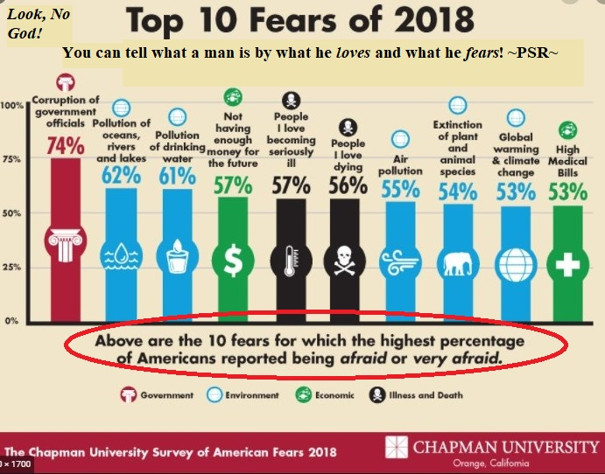

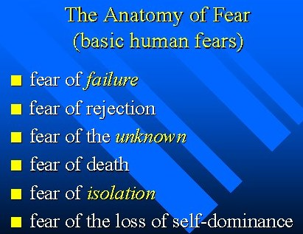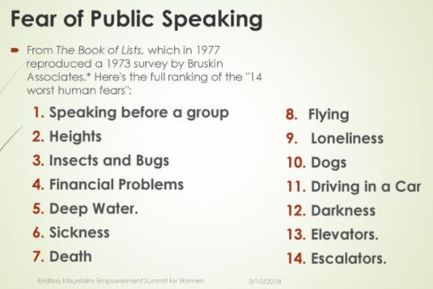

***Book 53.tifMan, the Measure of all Things?!***

ABCs of Christian Growth Page 19

WARS? WHAT WARS?!

Why, if you were to listen to the ***“Man, the measure of all things”*** tell it, there’s no war, but peace. Peace will be the end, because man is going to make it happen! Man is going to bring in everlasting peace and all men will live in one big warm fuzzy world and throw kisses to each other and hug and smile, and love will be everywhere!

Remember, we are here to check the fruit. The fruit is the way we know. Jesus said that,

Remember? ***Matthew 7:20***

The Lord Jesus Christ and the Prophet Jeremiah and others addressed peace and war, but, it is not the same as the world would address it. Look at the difference.

**PEACE**

“For they have healed the hurt of the daughter of my people slightly, saying, P _ _ _ _,

p _ _ _ _; when t _ _ _ _ i _ n _ p _ _ _ _. We looked for peace, but no good came; and for a

time of health, and behold trouble!” ***Jeremiah 8:11,15***

“P _ _ _ _ I l _ _ _ _ with you, m _ p _ _ _ _ I give unto you: n _ _ a _ t _ _ w _ _ _ _ giveth, give I unto you. Let not your heart be troubled, neither let it be afraid.” ***John 14:27***

“These things I have spoken unto you, that i _ m _ y _ m _ _ _ _ h _ _ _ p _ _ _ _. In the world ye shall have tribulation: but be of good cheer; I have overcome the world.” ***John 16:33***

**WAR**

“T _ _ _ _ n _ _ that I am come t _ s _ _ _ p _ _ _ _ on earth: I came not to send peace, b _ _ a

s _ _ _ _. ***Matthew 10:34***

“From whence come w _ _ _ and f _ _ _ _ _ _ _ _ among you? come they not hence, even of your lusts that war in your members? Y _ l _ _ _, and have not: y _ k _ _ _, and desire to have, and cannot obtain: y _ f _ _ _ _ and w _ _, yet ye have not, because ye ask not.” ***James 4:1,2***

“As it is written, There is none righteous, no, not one: There is none that understandeth, there is none that seeketh after God. They are all gone out of the way, they are together become unprofitable; there is none that doeth good, no, not one. Their throat is an open sepulchre; with their tongues they have used deceit; the poison of asps is under their lips: Whose mouth is full of cursing and bitterness: Their feet are s _ _ _ _ t _ s _ _ _ b _ _ _ _: D _ _ _ _ _ _ _ _ _ _ and m _ _ _ _ _ are in t _ _ _ _ w _ _ _: And t _ _ w _ _ of p _ _ _ _ have they n _ _ k _ _ _ _: There is no fear of God before their eyes.” ***Romans 3:10-18***

Book 53.tifMan says there is peace and HE is going to make it happen! The Lord and the Prophets say there is not, and it will not happen until Jesus Christ the King comes back. Who’s right? ***Check the Fruit!!! Man, the Measure of all Things!***

ABCs of Christian Growth Page 20

Below are charts of actual wars and battles that have taken place and some that are still ongoing, in their different time periods. Peace? Only the First page of the first chart and the last page of the last chart are enlarged to show the multitude of wars. If you would like the charts they are available. *(And these are just the ones that are known about and recorded!)*

***Man, The Measure of all Things?!***

**218 Pages of Wars/ 2265 Wars (Conflicts)**

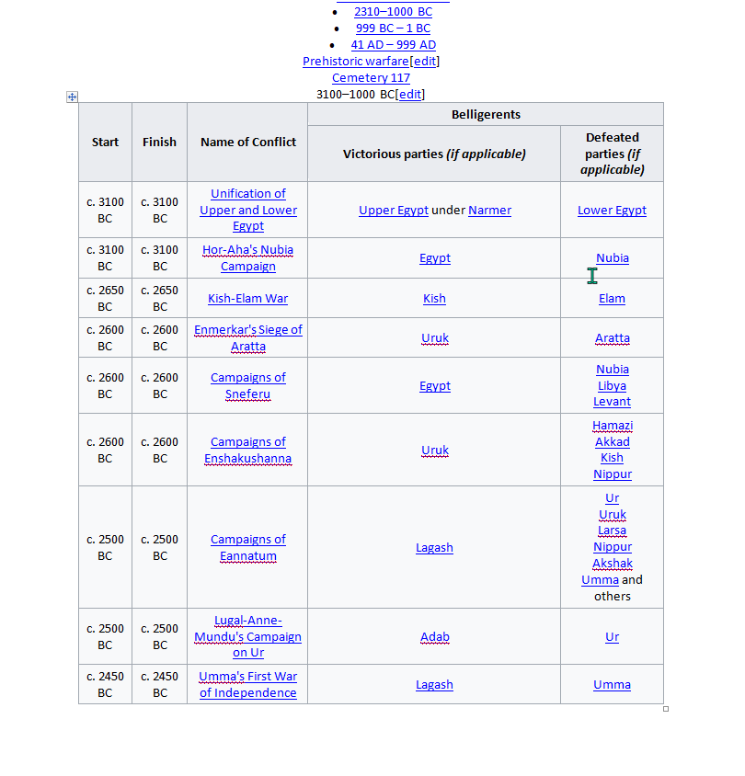

9 wars

Book 53.tif

ABCs of Christian Growth Page 21

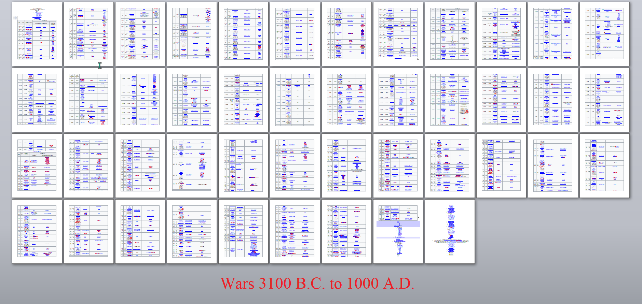

475 Wars/45pages



295 Wars/24pages



430 Wars/37pages



Book 53.tif

481 Wars/41pages

ABCs of Christian Growth Page 22

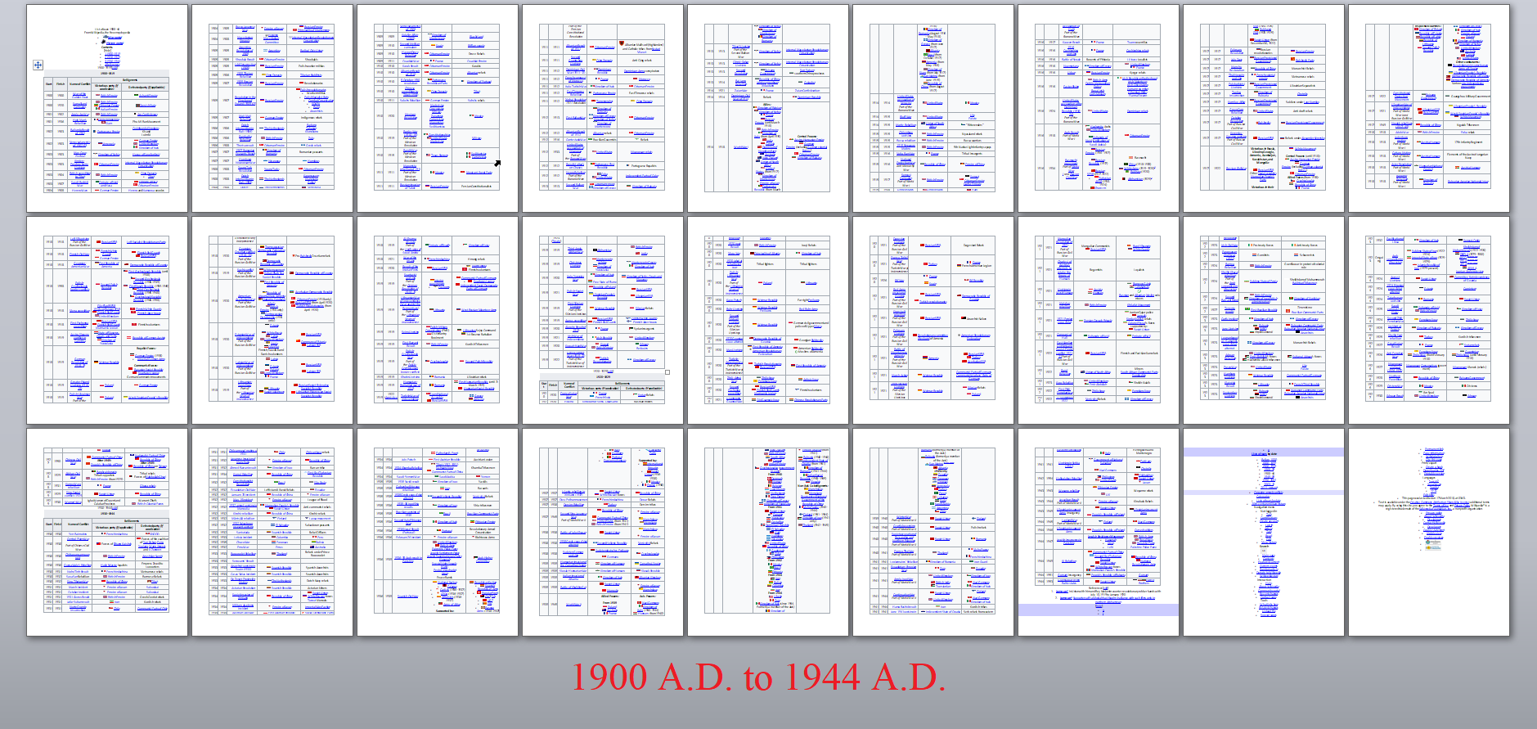

234 Wars/25pages



203 Wars/23pages

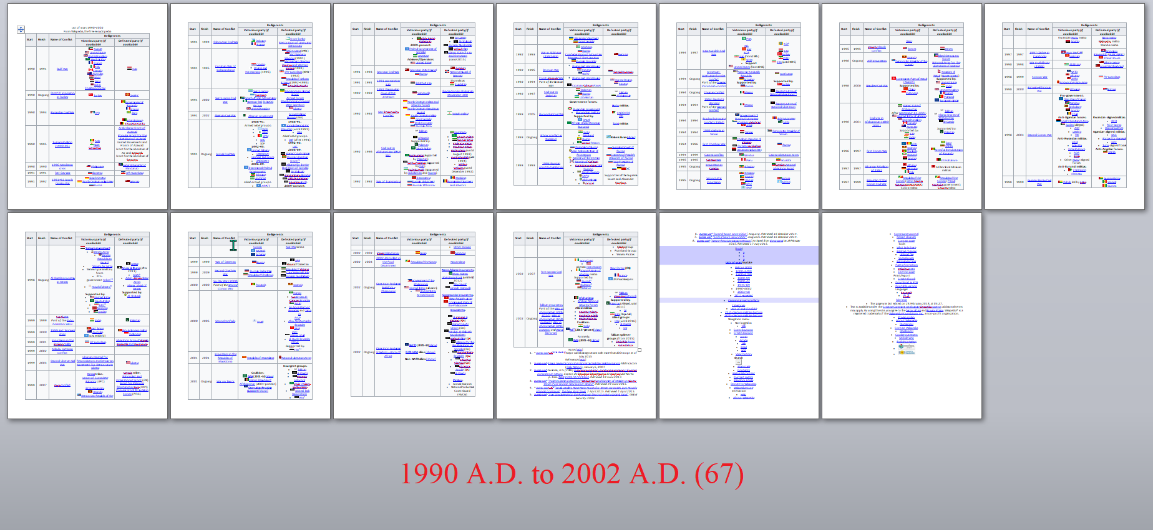

69 Wars/11pages

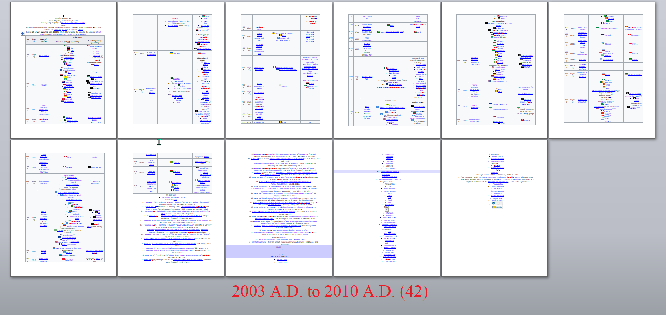

43 Wars/8pages

Book 53.tif

ABCs of Christian Growth Page 23



35 Wars/4pages

**5117 Years divided by 2265 Wars equals {1 War every 2.259 years}**



Book 53.tif

9 Wars

ABCs of Christian Growth Page 24

Gonna bring in peace and a kingdom, Aye? By the looks of it, it’s a wonder that there is anyone left. So who do you believe, ***“Man, the Measure of all things”*** or Jesus Christ, the word of God and the Prophets? The ***“Man, The Measure of All Things”*** has educated himself well on how to kill and war with his own kind, but there’ll be no peace until the “Prince of Peace” gets here and sets up His Kingdom. Maybe “cease fires” to re-load, but not peace.

“For unto us a child is born, unto us a son is given: and the government shall be upon his shoulder: and his name shall be called Wonderful, Counsellor, The mighty God, The everlasting Father, T _ _ P _ _ _ _ _ o _ P _ _ _ _.” ***Isaiah 9:6***

Unsolved Problems of Man Right Now

If man stopped everything around the entire world and all men come together in “unity,” (like they will try to do again) how long would it take Man to solve just the problems listed below? 1 year? 5 years? 10 years? How long? Answer: “NOT POSSIBLE!” Why? These are not the problems! These are the SYMPTOMS of the problem. So, what is the problem? ***“MAN, THE*** ***MEASURE OF ALL THINGS”*** of course. Man is the problem.

* “The Curse” – Pain; Suffering; Disease; Starvation; Birth defects; Death rate (Still 100%); Earthquakes; Tornados; Hurricanes; Floods; Droughts; Famine; Mudslides; Thunderstorms; Lightning strikes; Avalanches; Blizzards; Tidal waves; Tsunamis.
* 2nd Law of Thermodynamics - “There is ENTROPY in a closed system.”
* Abortion (2000 per day conservative est.)
* Arson
* AUTHORITY (Who’s in charge)
* Bad business
* BIBLE (THE BOOK)
* Bombings
* Cannibalism (growing human meat for selling and eating.)Really! Really!
* Capital Punishment
* Children aborting children
* Children fornicating
* Children how to use condoms
* Children Suicide
* Corona virus
* Crime
* Cross dressers
* Death
* Debt
* Deceit

Book 53.tif

ABCs of Christian Growth Page 25

* Differences between the Sexes (at beginning of Covid-19) (Men 17xxx; Women 17xxx; “UNKNOWNS” 33)Unknowns could not be (Identified) as either Male or Female!
* Dignity Failing
* Drinking deaths
* Drought
* Drug Trafficking
* Earthquakes
* Environmental pollution
* Envy
* Equal rights demanders
* Euthanasia
* Eternal punishment
* Eternity
* False advertisements
* Famine
* Fatal Diseases
* Fear
* Fires
* Flies and gnats
* Floods
* Flu
* Food supply, farming
* Fornication
* Gender Identity nuts
* Generation digression
* GOD
* Gun laws (Owning weapons)
* Hate Crimes
* Headache
* Health Problems (Cancer, Heart Diseases; etc.)
* Heaven & Hell
* How to get off of this planet (You would think someone knows something is going to happen to this one, huh?) (Billions of dollars of thinking so.)
* Human trafficking
* Hurricanes
* Integrity
* International Terrorism
* Jobs, unemployment, work
* Lie’s & Lying
* Lightning strikes

Book 53.tif

ABCs of Christian Growth Page 26

* Living without education of the truth
* Lust
* Man is the only one on the planet that would let their fellow human beings live in the streets and in the filth of humanity all the while putting aside thousands of acres of “sacred” land for sacred animals, and think it is the right thing to do.
* Mankind killing each other (Started with Cain and no one has stopped it yet)
* Minority Train
* Morality
* Murder
* Mass shootings
* News-media
* Nuclear threats
* Old age
* Pain
* Peace process
* Phone call liars and cheats.
* Plane Crashes (2015-One major Crash a week)
* Poisons
* Pride
* Prison population U.S.A. is 5% of the world population and houses 25% of the worlds prisoners.
* Punishment of the wicked
* Races (differences)(Racism)
* Religious disunity
* Right and wrong (Who decides)
* Rights “I know my rights”
* Roach, rats, insect’s infestation
* Safety
* Sanity
* Satan Worship
* Save the animals
* Saving natural resources
* School Systems, not the ABCs anymore folks
* Science so-called
* Security Lock it up
* Segregation
* Self-defense means go to jail Bad is good and good is bad now.
* Sex perversion
* Sexual promiscuity
* Sin

Book 53.tif

ABCs of Christian Growth Page 27

* Sorcery and the legal dope making pharmaceuticals
* Starvation
* Stealing, lying, cheating
* Suicide
* Theft
* Tornado’s
* Tsunami’s
* Unification efforts from Babel
* War (54 between 1912-1992)
* Watch runs down; Car breaks down; Battery runs out of juice; Food spoils; Grow old

and die.

* What’s out there? Hubble telescope
* Why people are always searching to be anybody else but what they are.
* Women wanting to be in charge. Domineering imaginative escape from God and reality.
* Women are really men because they say so. Men are really women because they say so. And a countries authorities backs up the preposterous claims.
* When asked on a documentary about soldiers experiences over in Vietnam concerning killing others, (Title-First Kill) they all agreed it was like having sex. They did not know why they answered this way only that it was true. MANS FALLEN NATURE! LUST!

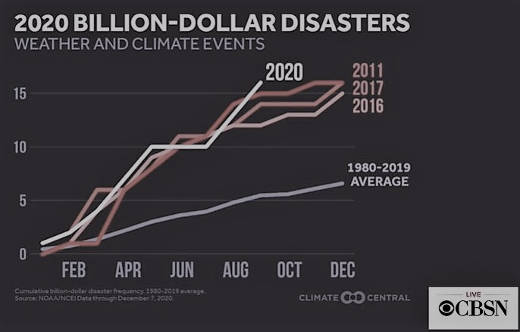



Book 53.tif

ABCs of Christian Growth Page 28

“Measure, What Measure?

***Measure:*** Determine the measurements of something or somebody, take measurements of; Have certain dimensions; Estimate or determine the nature, value, quality, ability, extent, or significance of;

The Apostle Paul was and still is one of the greatest Born-Again men that ever lived and served the Lord. The Lord used Him to bring into being the New Covenant “the Gospel of the Grace of God.” He spoke about what he thought of himself as a man and what measure he thought he was worth. Look at some of the things he said as our example.

“For his letters, say they, are weighty and powerful; but his bodily presence is weak, and his speech contemptible. Let such an one think this, that, such as we are in word by letters when we are absent, such will we be also in deed when we are present. For w _ d _ _ _ n _ _ m _ _ _

o _ _ _ _ _ _ _ _ of the number, or c _ _ _ _ _ _ o _ _ _ _ _ _ _ _ with some that *commend themselves*: but they m _ _ _ _ _ _ _ _ t _ _ _ _ _ _ _ _ _ b _ t _ _ _ _ _ _ _ _ _, and

c _ _ _ _ _ _ _ _ t _ _ _ _ _ _ _ _ _ a _ _ _ _ t _ _ _ _ _ _ _ _ _, **are not wise**. But w _ w _ _ _

n _ _ boast of things w _ _ _ _ _ _ o _ _ m _ _ _ _ _ _, but according t _ t _ _ m _ _ _ _ _ _ o _

t _ _ r _ _ _ which G _ _ h _ _ _ d _ _ _ _ _ _ _ _ _ _ t _ u _, a m _ _ _ _ _ _ t _ r _ _ _ _ even

u _ _ _ y _ _. For we s _ _ _ _ _ _ n _ _ ourselves beyond o _ _ m _ _ _ _ _ _, as though we reached not unto you: for we are come as far as to you also in preaching the gospel of Christ:

N _ _ b _ _ _ _ _ _ _ o _ t _ _ _ _ _ without o _ _ m _ _ _ _ _ _, that is, of other men’s labors; but having hope, when your faith is increased, that we shall be enlarged by you according to our rule abundantly, To preach the gospel in the regions beyond you, and n _ _ t _ b _ _ _ _ i _

a _ _ _ _ _ _ m _ _ _ line of things made ready to our hand. But h _ that glorieth, l _ _ h _ _ glory i _ t _ _ L _ _ _.

**For not he that commendeth himself is approved, but whom the Lord** **commendeth**.”

***2 Corinthians 10:10-18***

After hearing what the Apostle Paul said, is this the frame of mind that man takes today? Are you kidding?! Paul said that Christians “are to go by the measure of the rule that God hath distributed to them.” Is this the way our thinking is? Is this the way our behavior is? Does anyone care? We should! We Better! Man, the Measure of all things! Ughhuhhh! Let’s look at some more of our Brothers leadership and example.

"I beseech you therefore, brethren, by the mercies of God, that ye present your bodies a living sacrifice, holy, acceptable unto God, which is your reasonable service. And be not conformed to this world: but be ye transformed by the renewing of your mind, that ye may prove what is that good, and acceptable, and perfect, will of God. For I say, through the grace given unto me, to every man that is among you, n _ _ t _ t _ _ _ _ o _ h _ _ _ _ _ _ m _ _ _ h _ _ _ _ _ t _ _ _ h _

o _ _ _ _ t _ t _ _ _ _; but to think s _ _ _ _ _ _, according as God hath dealt to every man the

Book 53.tifm _ _ _ _ _ _ of faith. For as we have many members in one body, and all members have not

ABCs of Christian Growth Page 29

the same office: So we, being many, are one body in Christ, and every one members one of another. Having then gifts differing according to the grace that is given to us, whether prophecy, let us prophesy according to the proportion of faith; Or ministry, let us wait on our ministering: or he that teacheth, on teaching;" ***Romans 12:1-7***

“It is not expedient for me doubtless to glory. I will come to visions and revelations of the Lord. I k _ _ _ a m _ _ i _ C _ _ _ _ _ above fourteen years ago, (whether in the body, I cannot tell; or whether out of the body, I cannot tell: God knoweth;) such an one caught up to the third heaven. And I k _ _ _ s _ _ _ a m _ _, (whether in the body, or out of the body, I cannot tell: God knoweth;) How that he was caught up into paradise, and heard unspeakable words, which it is not lawful for a m _ _ to utter.” Of such an one will I glory: y _ _ o _ m _ _ _ _ _ I w _ _ _

n _ _ g _ _ _ _, but in mine infirmities. For though I would desire to glory, I s _ _ _ _ n _ _ b _ a f _ _ _; for I will say the truth: but now I forbear, l _ _ _ a _ _ m _ _ s _ _ _ _ _ t _ _ _ _ o _

m _ a _ _ _ _ that which he seeth me to be, or that he heareth of me. And lest I should be

e _ _ _ _ _ _ a _ _ _ _ m _ _ _ _ _ _ through the abundance of the revelations, there was

g _ _ _ _ t _ m _ a t _ _ _ _ in the flesh, the messenger of Satan to buffet me, **lest I should be exalted above measure**.” ***2 Corinthians 12:1-7***

Do you see the attitude and the position that the Apostle Paul took. He made it a point to say that he was a privileged man to have gotten to do, see, hear and learn all that he had, and that if he wanted to stand up and say ***“Look at me, I am a Man, the Measure of all things,”*** he probably could had and had people to honor him in that way. But he didn’t. He was given a thorn in the flesh, not out of anger from the Lord, but from the Lords care. The Lord knew that Paul was a “man” and helped him through a messenger of Satan to stay **in his measure**, and not get puffed up. What an example, don’t you think? You say, “Brother I don’t want a messenger of Satan on me!” Right?! Then I would find out God’s rule of measure for me and ***stay in it***!

***Man, The Measure of All Things!***

HEHAAAHEHAWHEHEHEHEHEHAHAAHAHA HEHAW HEHAW HEHAW!!!

And one peculiar thing about it is that some of you were just offended by that laugh! That is us! That’s how we be. That old man does not want anyone mentioning anything that would distort his image(ination.) Yah know?

Mans True Measure

Alright. We have studied long and thoroughly about man and his measure. By now we know all about man and his beginning, his present state, his final state, the Lords relation to man, some aspects of man, ways men die, what men are scared of, all of the fighting he has been doing, and

Book 53.tif

ABCs of Christian Growth Page 30

the problems that keep on getting worse no matter what his efforts. By now, if you are not saved, you should know that you are in a mess that you cannot get out of yourself. This is what the Lord Jesus Christ done for us. He died, was buried and rose from the dead, because He both loved and cared about you, and did not want you to end up in the Lake of fire, forever in this state. If you are not saved, or not sure, when this class is over or whenever you finish this lesson, whichever, **BUT TODAY**, go to the teacher and get your Salvation settled once and for all. Please do not wait. **Today friend, Today!** As for all Born-Again Bible Believers, the following is what the Scriptures say should be your true measure since you have been saved out of such a terrible state.

“I therefore, the p _ _ _ _ _ _ _ of the Lord, beseech you that y _ w _ _ _ w _ _ _ _ _ of the

v _ _ _ _ _ _ _ wherewith y _ are called, W _ _ _ all lowliness and meekness, w _ _ _ longsuffering, forbearing one another in love; E _ _ _ _ _ _ _ _ _ _ to keep the unity of the Spirit in the bond of peace. There is one body, and one Spirit, even as y _ a _ _ c _ _ _ _ _ in one hope of y _ _ _ calling; One Lord, one faith, one baptism, One God and Father of all, who is above all, and through all, and i _ y _ _ a _ _. But unto e _ _ _ _ o _ _ o _ u _ is given grace according to t _ _ m _ _ _ _ _ _ o _ t _ _ g _ _ _ of Christ. Wherefore he saith, When he ascended up on high, he led captivity captive, and gave gifts u _ _ _ m _ _. (Now that he ascended, what is it but that he also descended first into the lower parts of the earth? He that descended is the same also that ascended up far above all heavens, that he might fill all things.) And h _ g _ _ _ s _ _ _, apostles; and s _ _ _, prophets; and s _ _ _, evangelists; and s _ _ _, pastors and teachers; For t _ _ p _ _ _ _ _ _ _ _ _ of the saints, for t _ _ w _ _ _ of the ministry, for t _ _ e _ _ _ _ _ _ _ of the body of Christ: Till w _ a _ _ come in the unity of the faith, and of the knowledge of the Son of God, u _ _ _ a p _ _ _ _ _ _ m _ _, unto t _ _ m _ _ _ _ _ _ of t _ _ s _ _ _ _ _ _ of t _ _ f _ _ _ _ _ _ of C _ _ _ _ _: That we henceforth be n _ m _ _ _ children, tossed to and fro, and carried about with every wind of doctrine, by the sleight of men, and cunning craftiness, whereby they lie in wait to deceive; But s _ _ _ _ _ _ _ t _ _ t _ _ _ _ in love, may g _ _ _ u _ i _ _ _ h _ _ in a _ _ t _ _ _ _ _, which is the head, even Christ: From whom the whole body fitly joined together and compacted by that which every joint supplieth, according to the effectual working i _ t _ _ m _ _ _ _ _ _ of every part, maketh increase of the body unto the edifying of itself in love. This I say therefore, and testify in the Lord, that ye henceforth

w _ _ _ n _ _ as other Gentiles walk, in the v _ _ _ _ _ o _ t _ _ _ _ m _ _ _, Having the understanding darkened, being alienated from t _ _ l _ _ _ o _ G _ _ through the ignorance that is in them, because of the blindness of their heart: Who being past feeling have g _ _ _ _

t _ _ _ _ _ _ _ _ _ over unto lasciviousness, to work all uncleanness with greediness. But y _

h _ _ _ n _ _ so learned Christ; i _ s _ b _ that y _ h _ _ _ h _ _ _ _ him, and have b _ _ _

t _ _ _ _ _ by him, as t _ _ t _ _ _ _ i _ i _ J _ _ _ _: That ye put off concerning the f _ _ _ _ _ conversation t _ _ o _ _ m _ _, which is corrupt according to the deceitful lusts; And b _

r _ _ _ _ _ _ in t _ _ s _ _ _ _ of y _ _ _ m _ _ _; And that ye p _ _ o _ the n _ _ m _ _, which

a _ _ _ _ G _ _ i _ c _ _ _ _ _ _ in righteousness and true holiness. Wherefore putting away lying, speak e _ _ _ _ m _ _ t _ _ _ _ with his neighbor: for we are members one of another. Be ye angry, and sin not: let not the sun go down upon your wrath: Neither give place to the devil.

Book 53.tifABCs of Christian Growth Page 31

Let him that stole steal no more: but rather let him labor, working with his hands the thing which is good, that he may have to give to him that needeth. Let no corrupt communication proceed out of your mouth, but that which is good to t _ _ u _ _ o _ e _ _ _ _ _ _ _, that it may minister grace unto the hearers. And g _ _ _ _ _ n _ _ the holy Spirit of God, whereby y _ a _ _ s _ _ _ _ _ unto the day of redemption. Let all bitterness, and wrath, and anger, and clamor, and evil speaking, b _ p _ _ a _ _ _ f _ _ _ y _ _, with all malice: And be ye kind one to another, tenderhearted, forgiving one another, even as God for Christ’s sake h _ _ _ f _ _ _ _ _ _ _

y _ _.” ***Ephesians 4:1-32;1 Corinthians 13:11;Ecclesiastes 10:1***

Now, there is true measure! Praise the Lords Wonderful name!

The Final Measure

“For I say, through the grace given unto me, to e _ _ _ _ m _ _ that is among you, n _ _ t _

t _ _ _ _ of himself m _ _ _ h _ _ _ _ _ than h _ o _ _ _ _ t _ think; but to think soberly, according a _ G _ _ h _ _ d _ _ _ _ to every man t _ _ m _ _ _ _ _ _ of faith.” ***Romans 12:3***

“90% of people in any generation do exactly what dogs and cats do. They seek self gratification, self-preservation, and self-propagation. People and animals share the same basic drives. Only the New-Birth can give a human being a purpose for living and a set of values based on something beyond these three drives.” ~PSR~

“I said in mine heart concerning the estate of the sons of men, that God might manifest them, and that they might see that *they themselves are beasts*. For that which befalleth the sons of men befalleth beasts; even one thing befalleth them: as the one dieth, so dieth the other; yea, they have all one breath; so that a man hath no preeminence above a beast: for all is vanity. All go unto one place; all are of the dust, and all turn to dust again.”

***Ecclesiastes 3:18-20 ~King Solomon~ 1 Peter 1:24 ~Apostle Peter~***

“Among whom also we all h _ _ our conversation in times p _ _ _ in the lusts of our flesh, fulfilling the desires of the flesh and of the mind; and w _ _ _ by nature the children of wrath, even as others.” ***Ephesians 2:3***

“Therefore if a _ _ m _ _ be i _ C _ _ _ _ _, he i _ a n _ _ c _ _ _ _ _ _ _: old things are passed away; behold, a _ _ t _ _ _ _ _ are b _ _ _ _ _ n _ _. ***2 Corinthians 5:17***

Mans condition - **Creation**

Mans condition - **man**

Mans condition - **the garden**

Mans condition - **the fall**

Mans condition - **the flood**

Book 53.tifMans condition - **Noah’s family repopulate the earth**

ABCs of Christian Growth Page 32

Mans condition - **Jews chosen by God and promises made**

Mans condition - **Jews 400+ years in Egypt**

Mans condition - **the Exodus**

Mans condition - **The Law is Given**

Mans condition - **the Conquering of the promised land**

Mans condition - **400 silent years**

Mans condition - **the 1st Advent of Christ**

Mans condition - **the Gospel of the Kingdom**

Mans condition - **the Rejection of the King**

Mans condition - **the Death, Burial, and Resurrection**

Mans condition - **Transition from the O.T. Salvation to N.T. Salvation**

Mans condition - **the Jew goes aside, the Gentile comes aboard**

Mans condition - **the Ascension**

Mans condition - **the Indwelling Holy Ghost**

Mans condition - **the Gospel of the Grace of God**

Mans condition - **the Church (the Body of Christ) (7 periods of changes for the**

**Church)(Ends in Apostasy)**

Mans condition - **the Catching away (Rapture) (Private)(The Church leaves)(Holy Ghost**

**Leaves)(Gospel of the Grace of God no more)**

Mans condition - **the Antichrist (Man of Sin on the scene)**

Mans condition - **the Great Tribulation period begins (7 years divided into two 31/2 year**

**periods)(the Great Whore)(Daniels 70th week)(the Time of Jacobs trouble)**

Mans condition - **Gentiles out/ deceived by the Man of Sin**

Mans condition - **Works of the Law for Salvation/Law reinstituted**

Mans condition - **Antichrist/Beast/ False Prophet trusted worldwide**

Mans condition - **Abomination of Desolation committed**

Mans condition - **Jews escape to the desert**

Mans condition - **Christ appears to the Jews as Messiah/Jews accept Christ**

Mans condition - **144,00 Jews preach Faith in Christ/works of the Law for salvation**

Mans condition - **post Tribulation Saints raptured**

**(just before the 2nd Advent)**

Mans condition - **2nd Advent of Christ (Day of the Lord) (Armageddon)**

Mans condition - **Satan's bound**

Mans condition - **Jews restored to their Land**

Mans condition - **1000 year worldwide Reign of Christ from Jerusalem**

**~Capital of the World~(the millennium)**

Mans condition - **Satan loosed for final time**

Mans condition - **the Great White Throne Judgment (The Lake of Fire)**

Mans condition – **Eternity (No more death, all enemies conquered)**

Book 53.tif

ABCs of Christian Growth Page 33

“The Lord Jesus Christ, The Measure of All Things”

“He must increase, but I must decrease. He that cometh from above i _ a _ _ _ _ a _ _: he that is of the earth is earthly, and speaketh of the earth: he that cometh from heaven i _ a _ _ _ _ a _ _. And what he hath seen and heard, that he testifieth; and no man receiveth his testimony. He that hath received his testimony hath set to his seal that God is true. For h _ whom G _ _ h _ _ _

s _ _ _ s _ _ _ _ _ _ _ the w _ _ _ _ of G _ _: for G _ _ g _ _ _ _ _ n _ _ t _ _ S _ _ _ _ _ b _

m _ _ _ _ _ _ u _ _ _ h _ _. The Father l _ _ _ _ _ t _ _ S _ _, and hath g _ _ _ _ a _ _ t _ _ _ _ _ i _ _ _ h _ _ h _ _ _. He that believeth on the Son hath everlasting life: and he that believeth not the Son shall not see life; but the wrath of God abideth on him.” ***John 3:30-36***

The Truth is that ***“Man, the Measure of all things”*** is indeed the ***“Measure of all Things.”*** That is, “THE SECOND MAN” the Lord from Heaven! Amen! ***1 Corinthians 15:47***

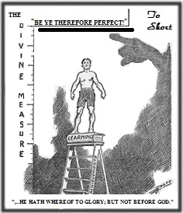

ABCs of Christian Growth Page 34