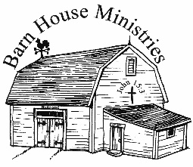Lesson #

Bibliology-The Wonders of the Bible

2

Lesson Commenced: ____________________ Lesson Completed: ____________________

* This is the second lesson on the greatest subject in the Bible, the source book from which all biblical doctrine is taken, ***the Bible*** itself. As you probably already know, the longest chapter in the entire Bible is *about the Bible*, ***Psalms 119***. So, when we study the Bible in these Theological Studies, we are studying the most important thing we probably will ever study, as all other doctrines are contingent upon its accuracy.

* Next to the gift of Christ and the Holy Ghost, the Bible is the greatest gift ever given to man. Next to the Lord Jesus Christ and the Holy Ghost, the kiss of God on the lost soul of man is the Holy Bible.

“I will worship toward thy holy temple, and praise thy name for thy lovingkindness and f _ _

t _ _ t _ _ _ _: for t _ _ _ hast m _ _ _ _ _ _ _ _ t _ _ w _ _ _ above all thy name.” ***Psalms 138:2***

Within this wondrous volumn lies

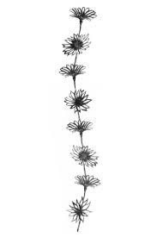The mystery of mysteries;

Happiest they of human race

To whom their God hath given grace;

To read, to fear, to hope, to pray

To lift the latch, to find the way;

And better they had ne’er been born

That read to doubt or read to scorn.

~Sir Walter Scott~

* Sir Walter Scott, himself the author of many books (who possessed a great library) said, “There is only one Book and that is the Bible!”

* John Wanamaker said, “That’s the Book. You ought to read it.”

* Robert E. Lee, the General of the Confederacy said, “That’s the Book. There is no Book like it.”

* The testimony of Ulysses S Grant, of John Quincy Adams, of Benjamin Franklin, and of Thomas Jefferson was that the Bible is a unique Book like no book in this world.

“Thy testimonies a _ _ w _ _ _ _ _ _ _ _: therefore doth m _ s _ _ _ keep them.”

***Psalms 119:129***

* The Bible is the oldest Book in existence.
* It required sixteen centuries to write it, and the first writer died 1,450 years before the last writer was born.
* Not one book in a thousand lasts more than five years. Not more than one book in ten-thousand lasts more than twenty years. There isn’t one book in one-hundred thousand books published that lasts more than one-hundred years.
* Three-quarters of the Bible was written before the Greeks had a civilization, and the Bible is still here after twenty-five centuries.
* The whole Bible was written before Mohammed or Buddha had finished their teachings. As a matter of fact, the whole Bible was written before Mohammed was born.

“Thou art my hiding place and my shield: _ h _ _ _ in t _ _ w _ _ _.” ***Psalms 119:114***

Seven Crowning Wonders of The Bible

1. **The wonder of its *Formation***

One book written in one place in one language, another book written in another country centuries later in another language, with all of them coming together to teach future events that have not yet taken place. Historically and Prophetically 100% accurate. Amazing!

“For ever, O LORD, t _ _ w _ _ _ i _ s _ _ _ _ _ _ in heaven.” ***Psalms 119:89***

The Old Testament was written before Jesus was born. The New Testament was written after Jesus was born, died, arose from the dead, and ascended into heaven.

1. **The wonder of its *Unification***

It is a library of sixty-six books, yet it is only one book, for it has but one Author, God the Holy Ghost. In all the attempts of the devil and his servants to corrupt the word of God there has never been proved conclusively that there is one mistake or contradiction in the Bible. The Lord said He would preserve it and He is.

“The w _ _ _ _ o _ t _ _ L _ _ _ are p _ _ _ w _ _ _ _: as silver tried in a furnace of earth, purified seven times. T _ _ _ shalt k _ _ _ t _ _ _, O LORD, t _ _ _ s _ _ _ _

p _ _ _ _ _ _ _ them from this generation for ever.” ***Psalms 12:6, 7***

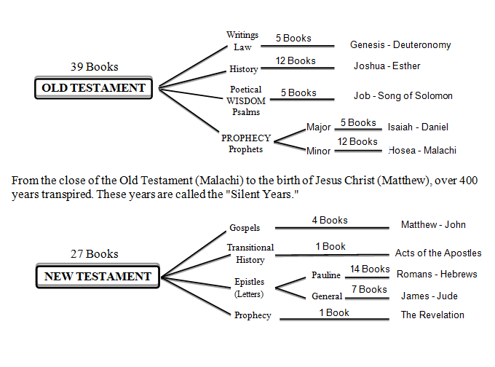



1. **The wonder of its *Age***

The Bible is by far the most ancient of all books. The Book of the Dead is not a real book, as anybody knows. The Book of the Dead is a compilation of scraps taken out of coffins in Egypt and assembled by somebody in a random, helter-skelter order to try to teach some kind of religion. You don’t find that in the word of God. There are whole chapters in the word of God that do not deal with religion at all. They deal with pure history. There are verses in the word of God that deal at length with philosophy and scientific facts.

The Bible hazards forty-eight prophecies about one individual (Jesus) before He is born. The Brahman, Hindu literature, Shastas, Puranas, Bhagavad-Gita or the Tripitaka would not even attempt that.

If you had the entire writings of every Hindu, Brahman and Buddhist who ever lived, you could not find as many prophecies about the history of America and Europe in 30,000 pages of their literature as you can in five pages of the Authorized Version.

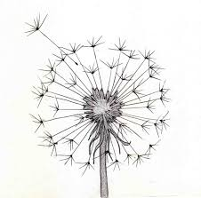“T _ _ w _ _ _ is true f _ _ _ t _ _ b _ _ _ _ _ _ _ _: and every one of thy righteous judgments e _ _ _ _ _ _ _ f _ _ e _ _ _. ***Psalms 119:160***

1. **The wonder of its *Sales***

The Bible is the best seller of all time, and it has always had more sales than any other two books combined. If you were to combine the number of sales of the NASV, old ASV, NIV and the Living Bible, they could not come up to half the sales of the King James Bible, which has put out 1,000,000,000 copies, sometimes at the rate of 20,000 a day, not counting the translations into 800 foreign languages. 809,000,000 copies since 1611.

All the other “Bibles” must adopt its *cover*, its *verse system*, its *chapter system*, its *concordance system*, its *reference system*, and its *print system*to stay on the bookshelves.

The King James 1611 Authorized Version is and sets the standard. Funny thing, but interesting enough that ALL other “Bibles versions” (214 and counting) that ever have been, are now, and will be, compare their books to the KJV1611. Not one another, but the KJV. Isn’t that interesting.

The Lords will is that everyone should have His word.

“Heaven and earth shall pass away, but m _ w _ _ _ _ s _ _ _ _ n _ _ passaway.”

***Matthew 24:35***

1. **The wonder of its *Interest***

The Bible is the only Book that is read by all classes and ages of mankind. It is read by Ph.D.’s and children. It is read by all nations. In Japan, India, South America, Mexico and Honduras you have two Bibles. You have the devil’s bible and you have the Lord’s Bible. If you don’t believe it contact the missionaries there and ask them. In America you have two Bibles, the Lord’s Bible and the devil’s Bible. The Lord’s Bible is the King James Bible, which comes from the Masoretic Text and the Textus Receptus. The devil’s bible is the Alexandrian Vaticanus and Sinaiticus, which are the background texts for all the others.

All men want to know what God says, even if it is for the wrong motives.

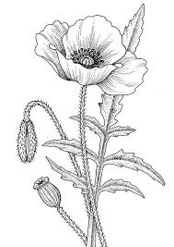“H _ _ s _ _ _ _ a _ _ t _ _ w _ _ _ _ unto m _ t _ _ _ _! yea, sweeter than honey to my mouth!” ***Psalms 119:103***

1. **The wonder of its *Language***

The Bible is written largely by uneducated men, yet it is considered a literary masterpiece. Only God could write a Book that speaks the language that can be understood by children to the most educated, without confusion, in every language and dialect and all who read it recognize the Author whether they acknowledge Him or not.

“Yet in the church I had rather speak five words w _ _ _ m _ u _ _ _ _ _ _ _ _ _ _ _ _, that by my voice I might t _ _ _ _ o _ _ _ _ _ a _ _ _, than ten thousand words in an

u _ _ _ _ _ _ tongue.” ***1 Corinthians 14:19***

1. **The wonder of its *Preservation***

It has been the most hated of all books. Fundamentalist make fun of it. Neo-Orthodox people hate it. Neo-Evangelicals ignore it. Nationwide evangelists suggest you get other bibles instead of it. Time and time again, kings and governments have sought to burn the King James Bible or abolish it. Yet God has graciously preserved it for us today, and it can be found in almost every home. There is nobody in America who cannot get a King James Bible in less than two hours from the time this class ends today. In spite of Christian scholarship and the Christian Universities and Colleges, we still have the infallible word of God in our own language, the King James 1611 Authorized Version.

In the study of church history there have been many people who have given their lives in both life and death for the Book.

“The Revelation of Jesus Christ, which God gave unto him, to shewunto his servants things which must shortly come to pass; and hesent and signified it by his angel unto his servant John:Who bare record of the word of God, and of the testimony of Jesus Christ, and of all things that he saw.Blessed is h _ t _ _ _ r _ _ _ _ _ _, and t _ _ _ t _ _ _ h _ _ _

t _ _ w _ _ _ _ of this prophecy, and keep those things which a _ _ w _ _ _ _ _ _ therein: for the time is at hand.” ***Revelation 1:1-3***



The Wonders of The Bible!